**1.**

Sampath Valluri – [svalluri1@uco.edu](mailto:svalluri1@uco.edu)

**2.**

**Project Implementation**

**Uploads User Images to S3:**The function decodes the base64-encoded images received from the frontend and uploads them to an S3 bucket.

**Face Detection & Comparison:**It uses AWS Rekognition to detect faces in the uploaded image and compares them against reference images (stored in S3) to determine if a match exists based on a similarity threshold.

**Name Extraction Using Textract:**In addition, the function uses AWS Textract to extract text from a pre-configured reference document image stored in S3. The extracted text is then compared to the student’s name provided on the frontend.

**Participation Decision:**If either a face match (face participation) or a text match (name participation) is found, the student is marked as having participated.

**Record Storage:**The final participation result, along with student details and processing information, is stored in a DynamoDB table.

**AWS Infrastructure Setup**

**API Gateway:**A REST API is created and configured (with CORS enabled) to serve as the public endpoint that triggers the Lambda function when a request is received from the frontend.

**AWS Lambda:**The Lambda function is the heart of the processing logic, handling image uploads, face detection/comparison, text extraction, and decision-making.It is configured with appropriate memory and timeout settings to handle the image processing workload.

**Amazon S3:**Two buckets are utilized: one for storing reference images (both for face and text extraction) and one for storing user-uploaded images.

**Amazon DynamoDB:**A DynamoDB table is set up to persist participation records with key attributes like email, class date, and student name.

**AWS Amplify:**Used to deploy and host the frontend web application, which collects user input and uploads images.

**Create an IAM Role with All Necessary Permissions**

**S3 Permissions:**Allow the Lambda function to read from and write to the specific S3 buckets using actions such as s3:GetObject, s3:PutObject, and s3:ListBucket.

**Textract Permissions:**Grant the function access to textract:DetectDocumentText (and textract:AnalyzeDocument if needed) to extract text from the reference image.

**Rekognition Permissions:**Permit face detection and comparison with rekognition:DetectFaces and rekognition:CompareFaces.

**DynamoDB Permissions:**Enable writing of participation records via dynamodb:PutItem.

**Testing:**

**Unit Testing:**The Lambda function is individually tested using sample test events (mimicking the payload from the frontend) to ensure that image uploads, face detection, text extraction, and DynamoDB writes work as expected.

**End-to-End Testing:**The complete workflow is tested from the frontend (using AWS Amplify) through API Gateway to the Lambda function.The DynamoDB table is checked to verify that participation records are correctly stored.

**3.**

**Screenshots**

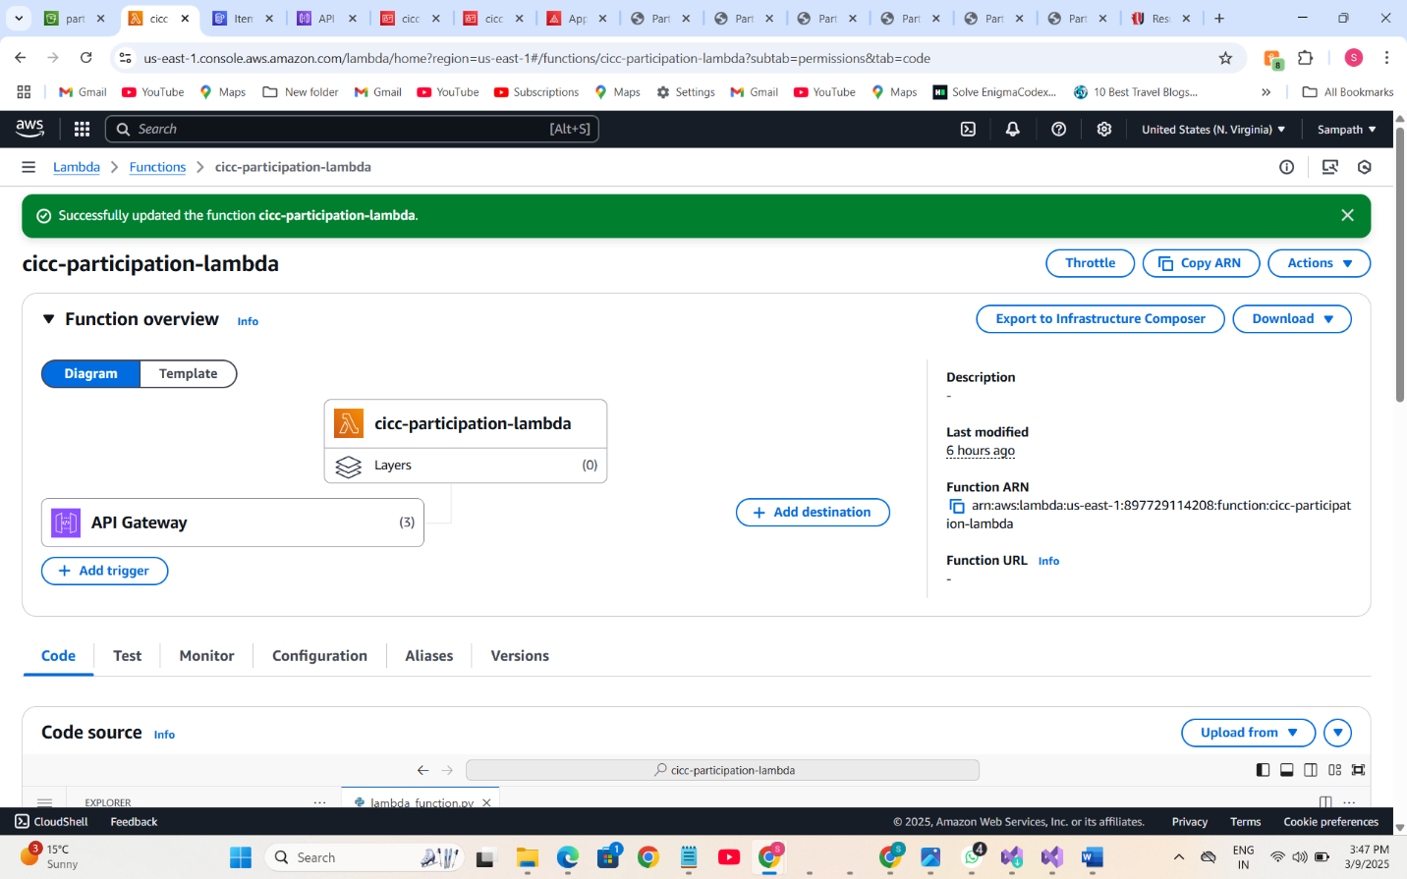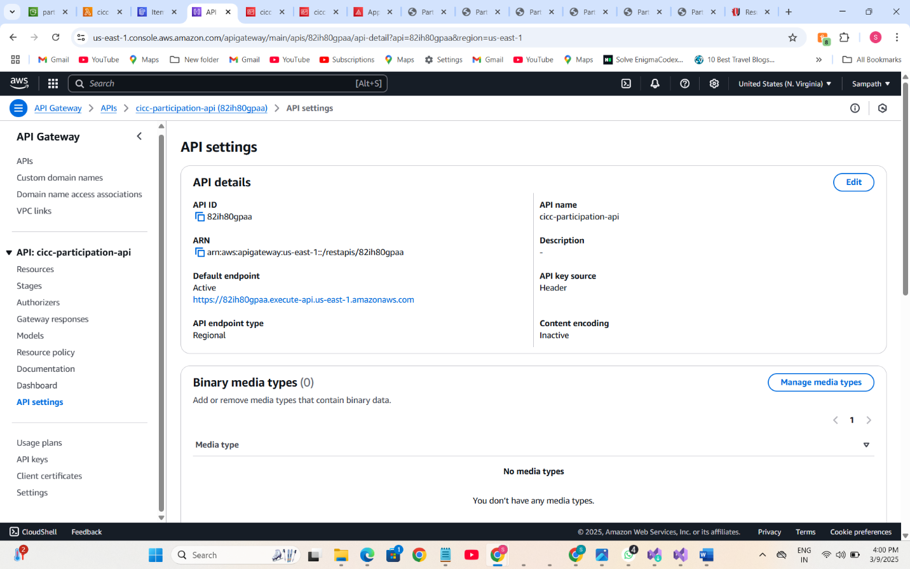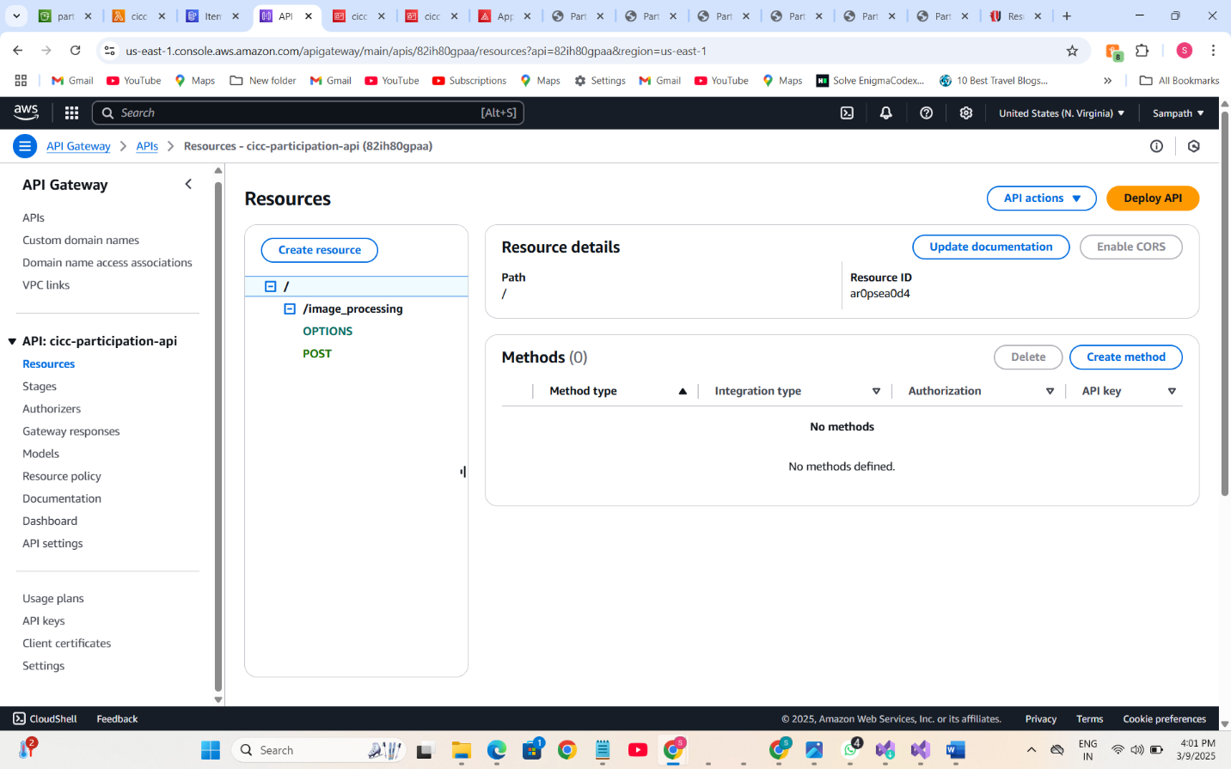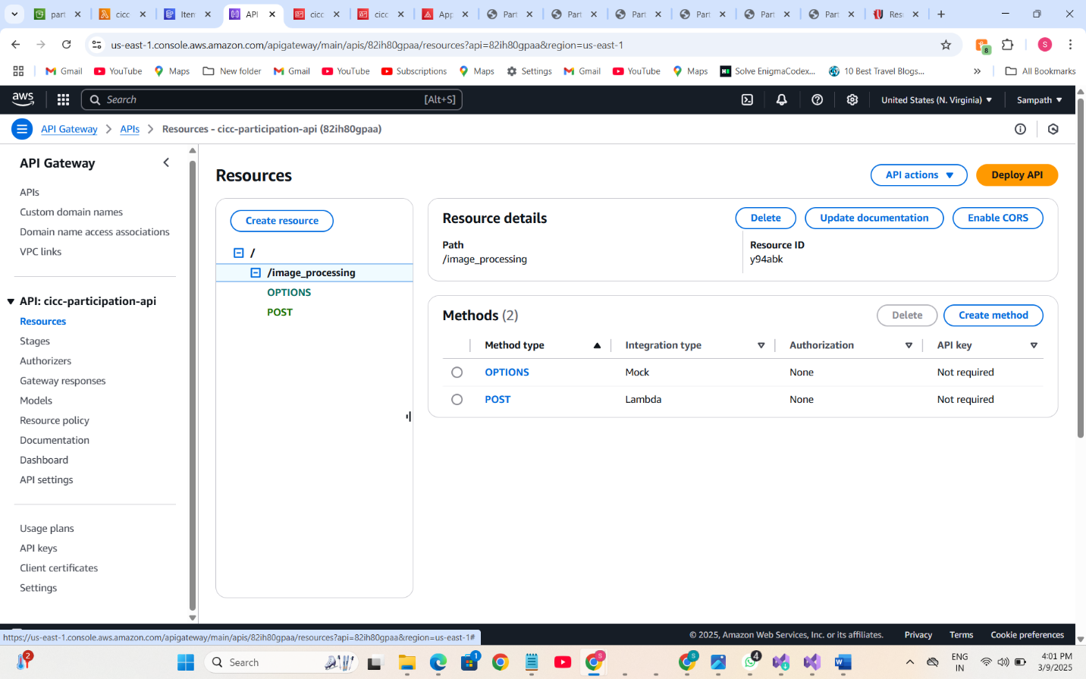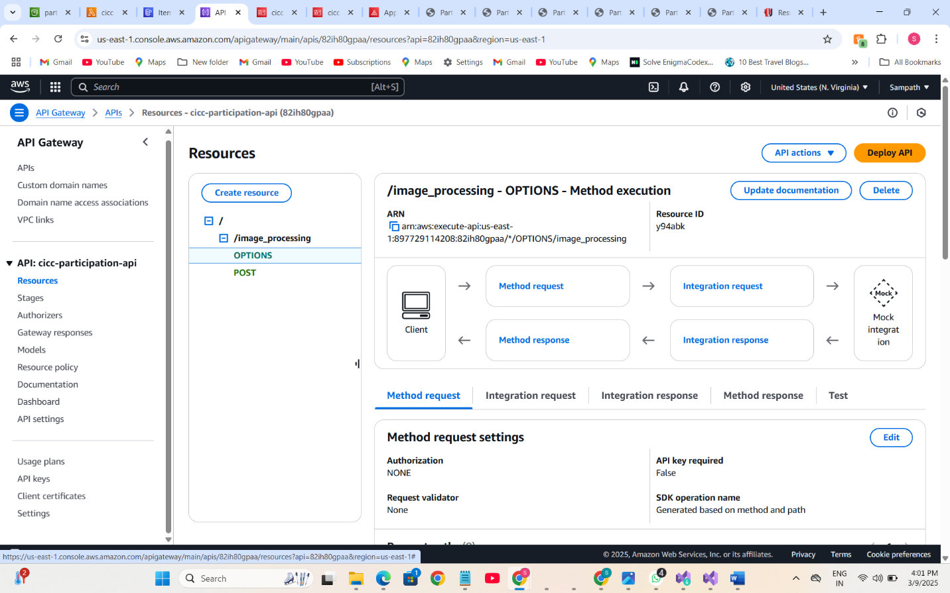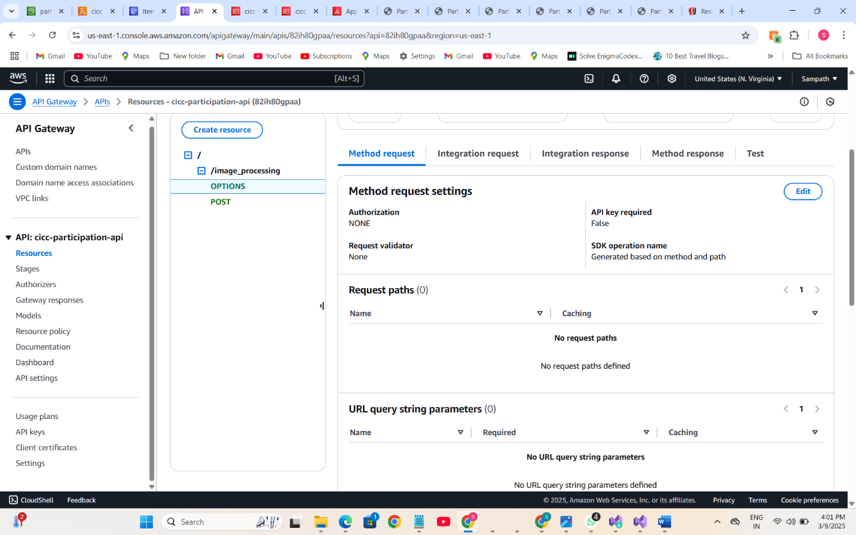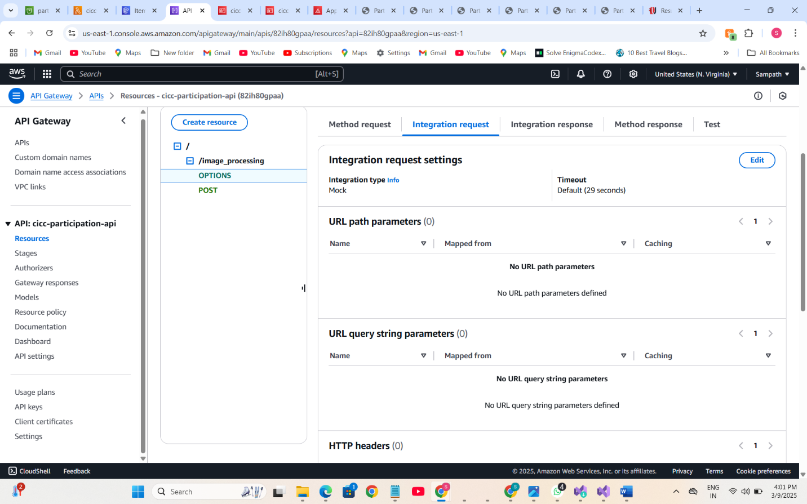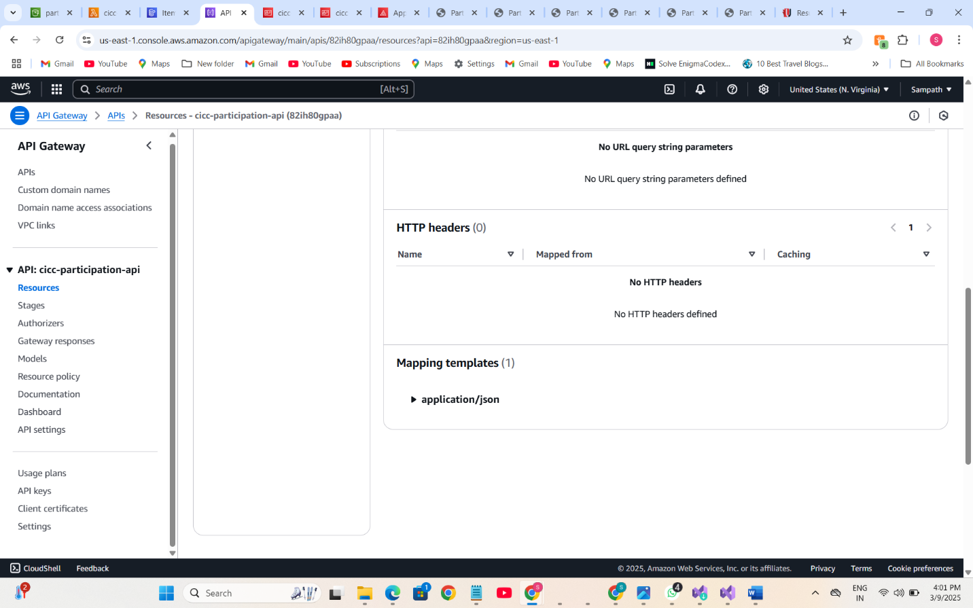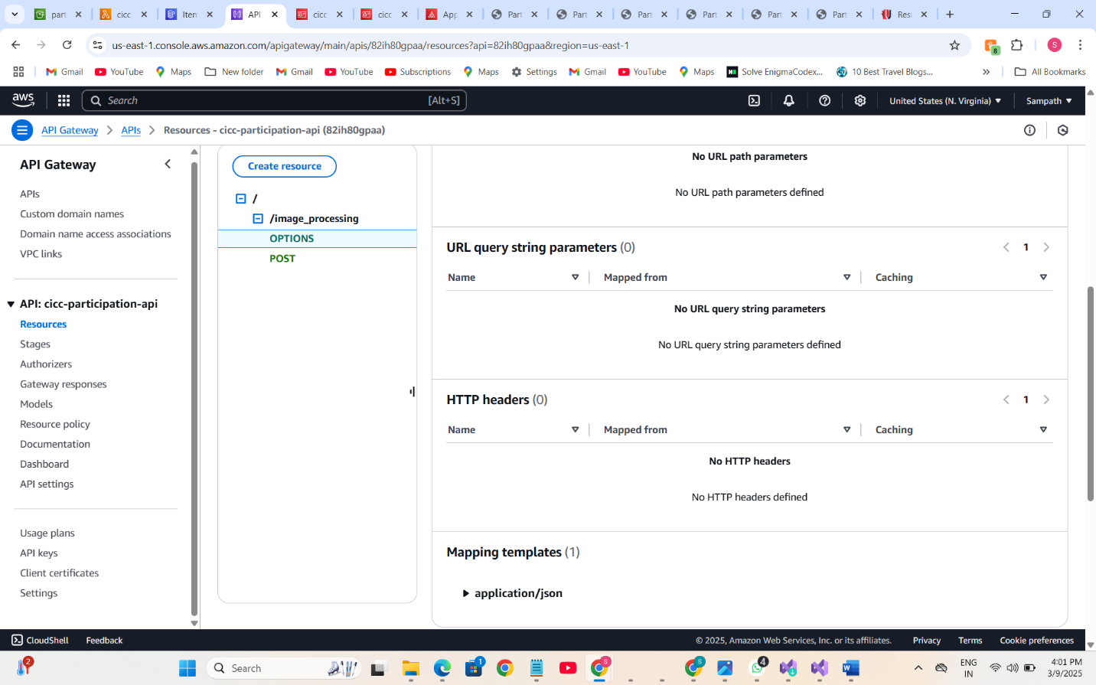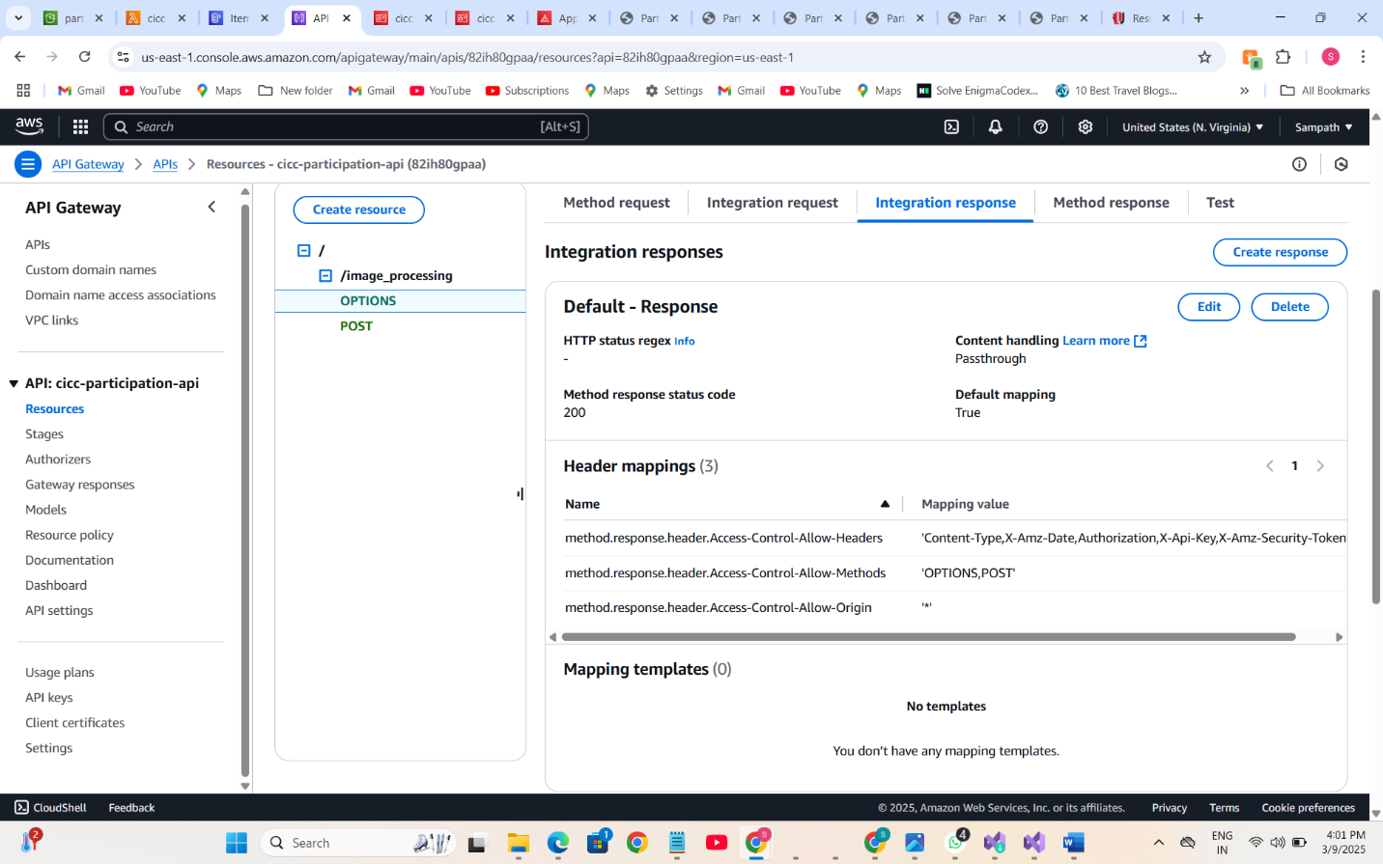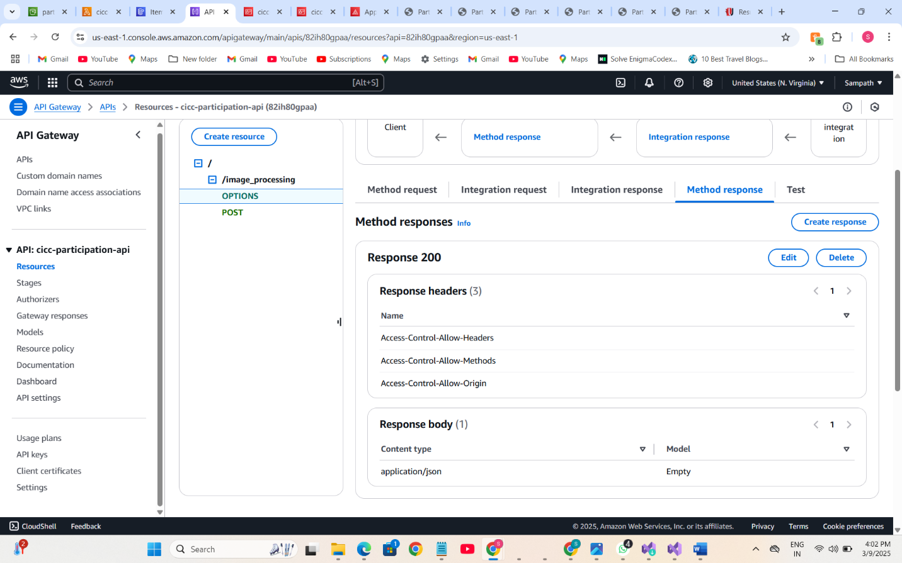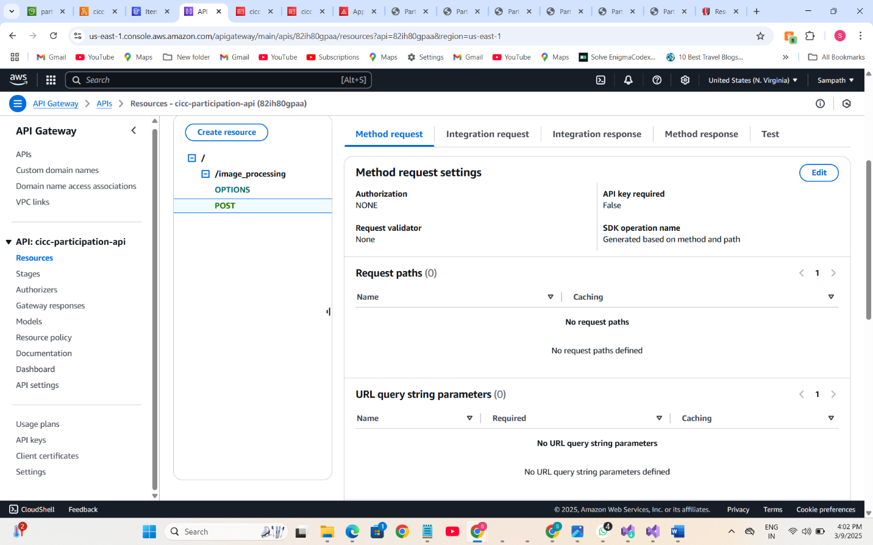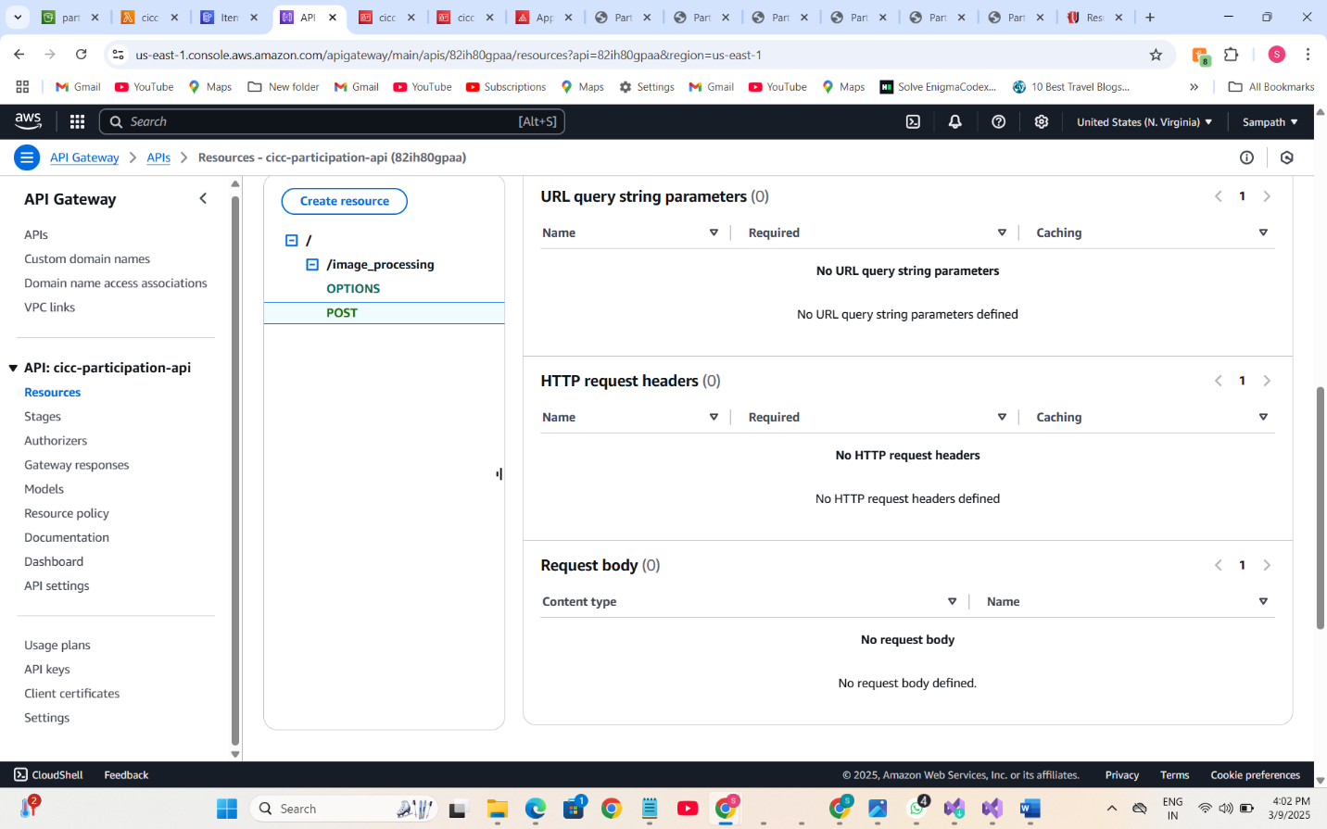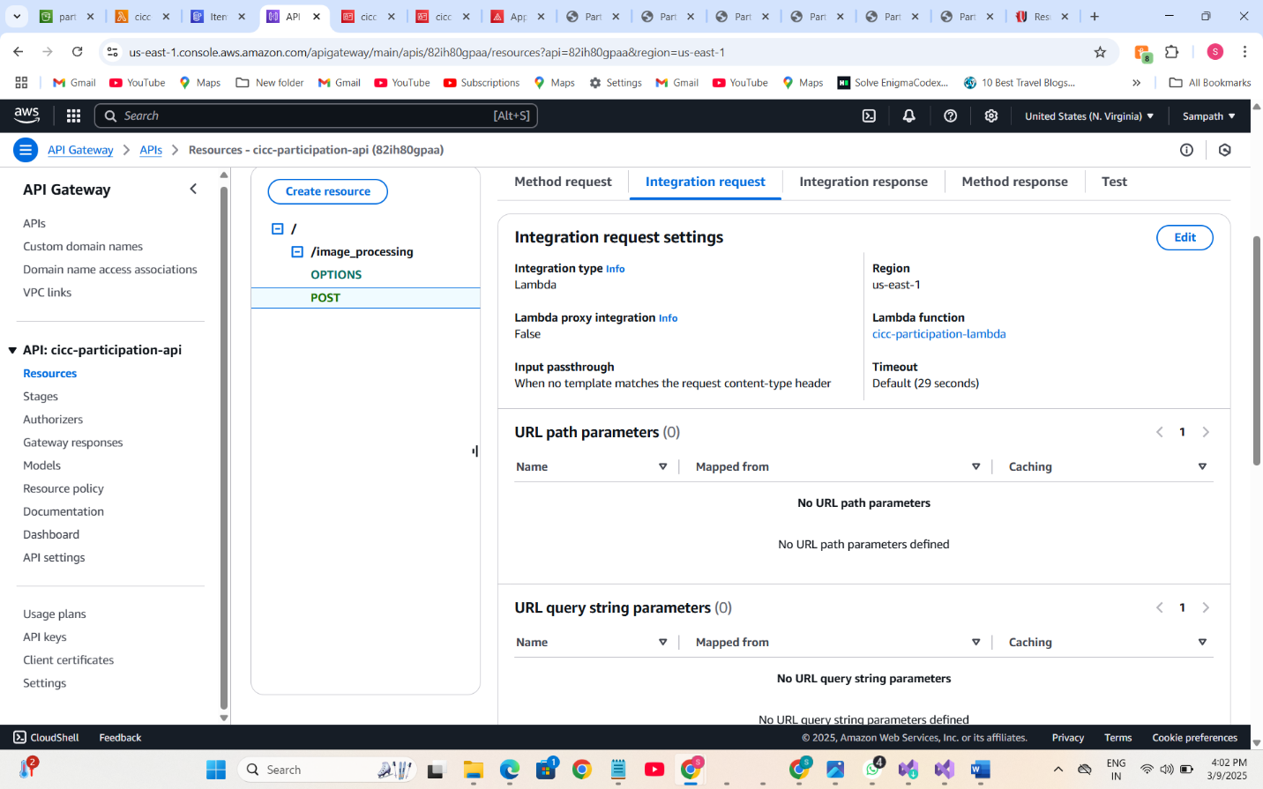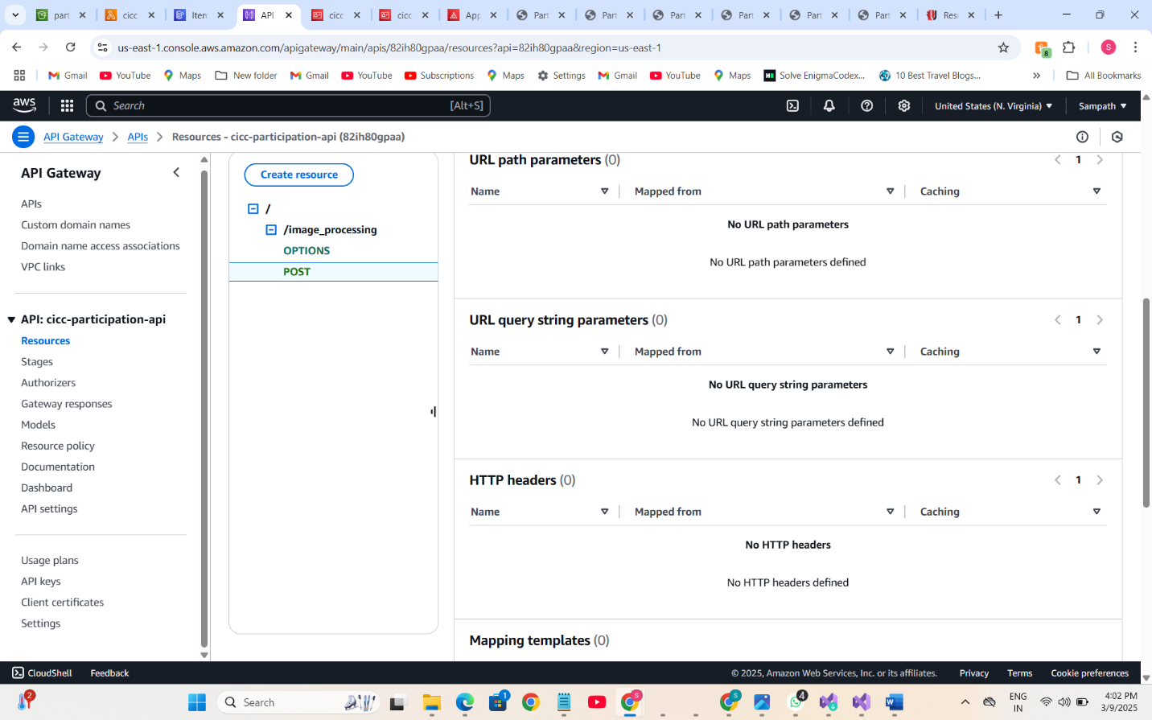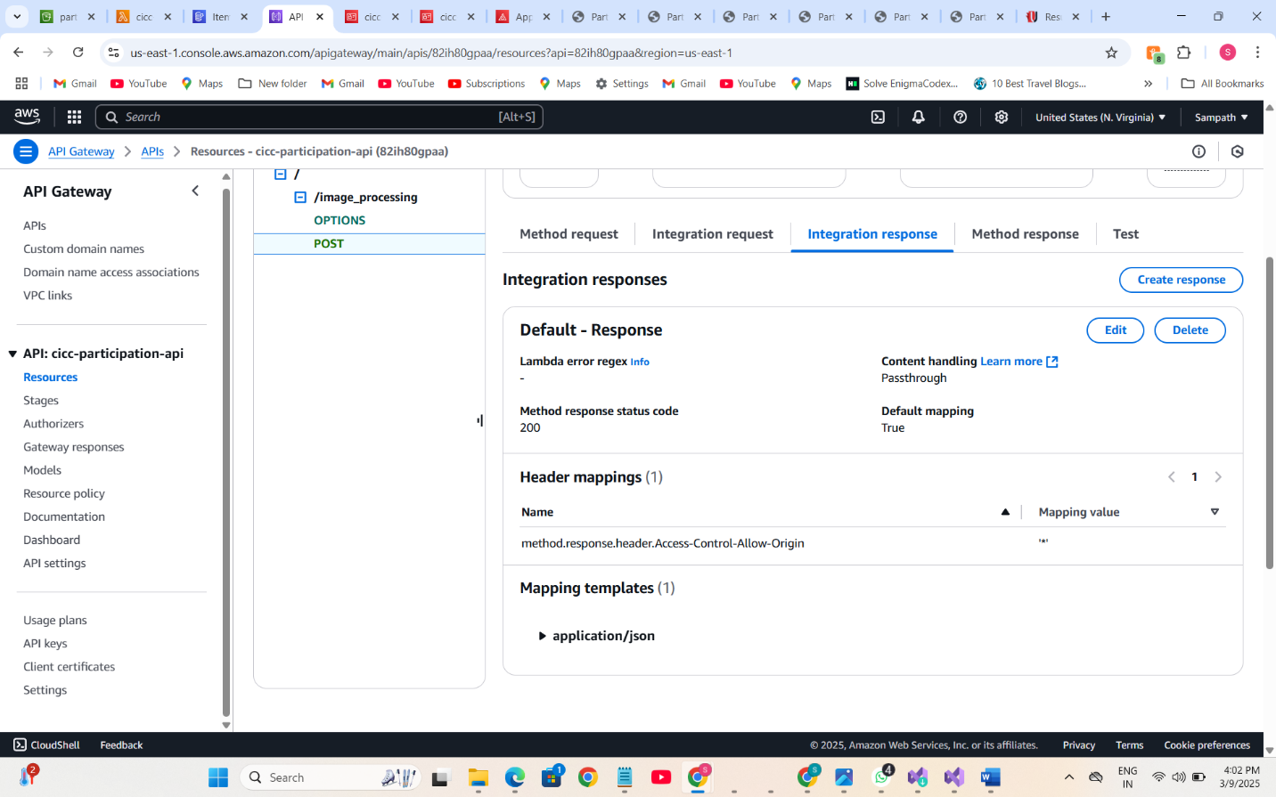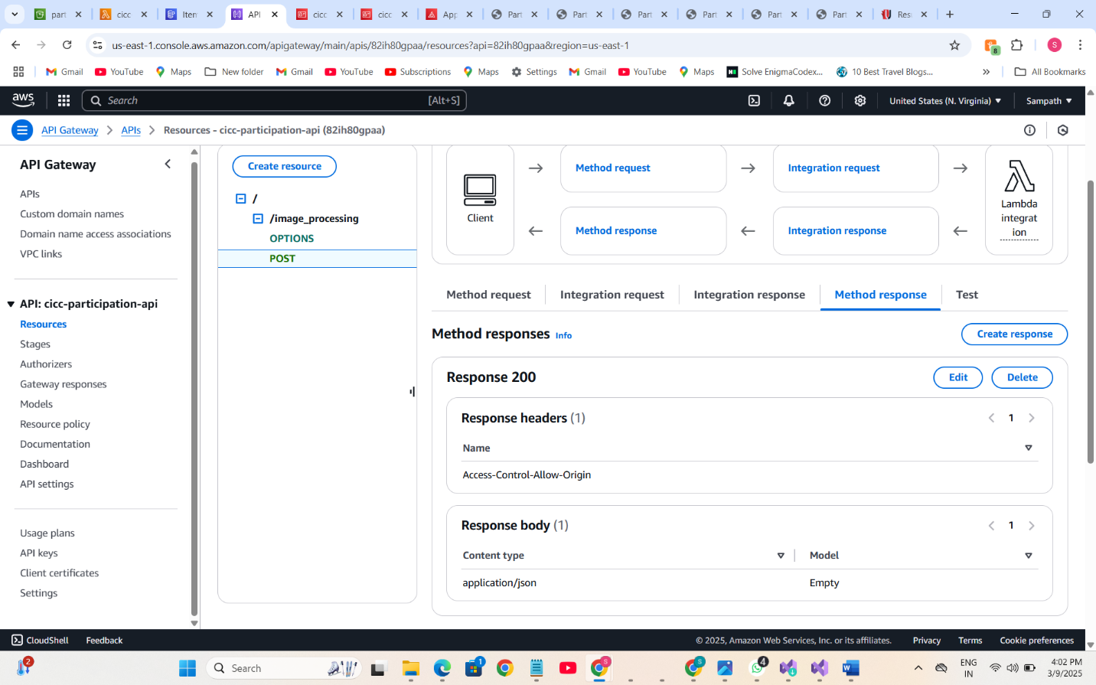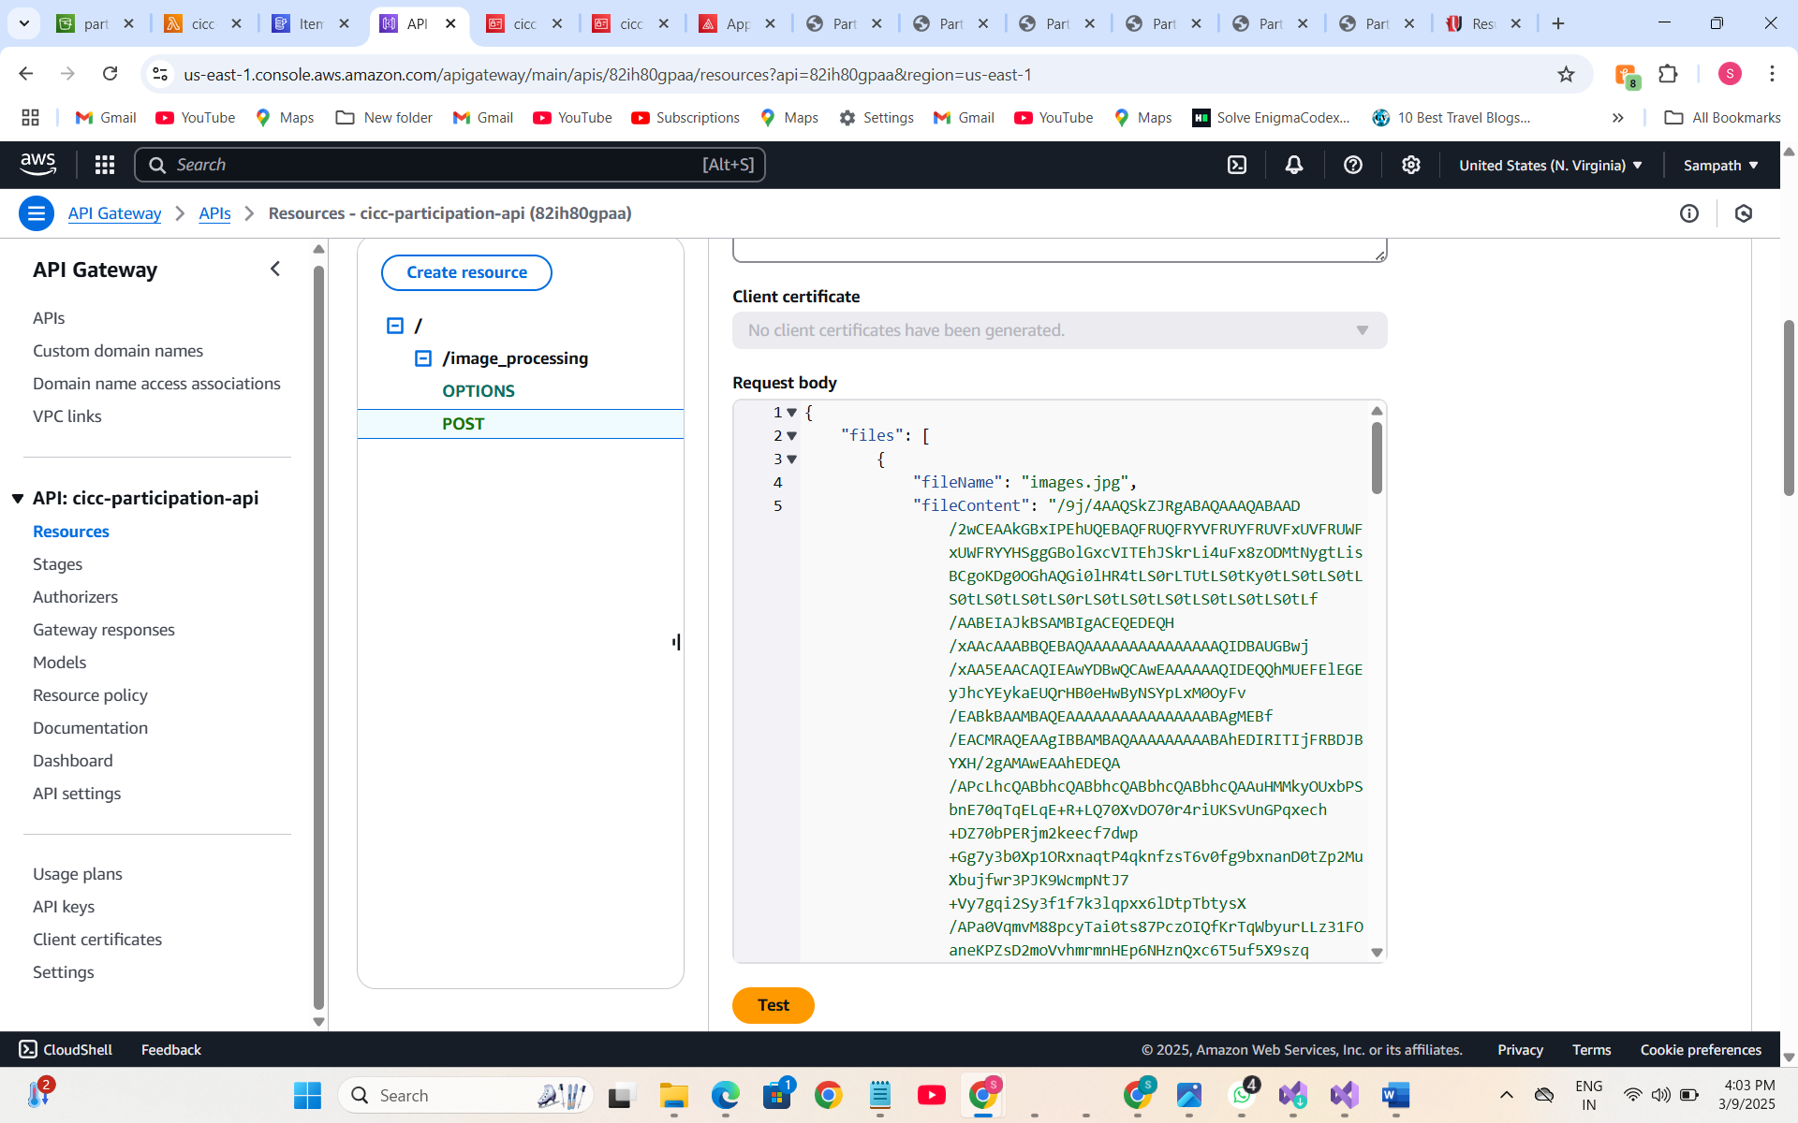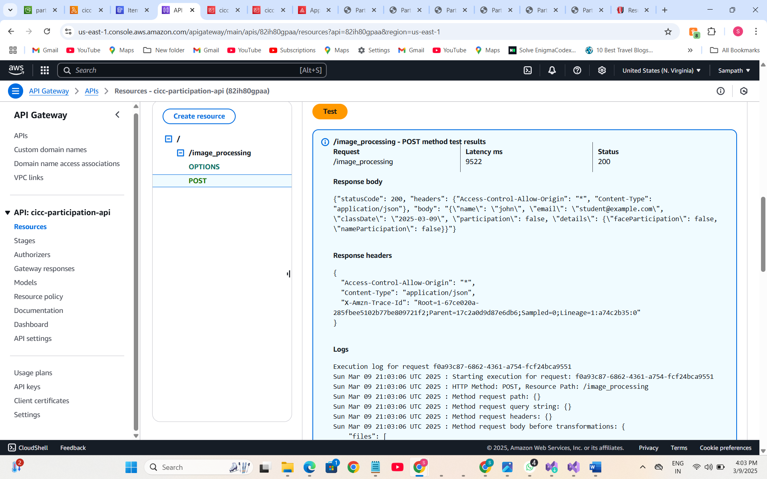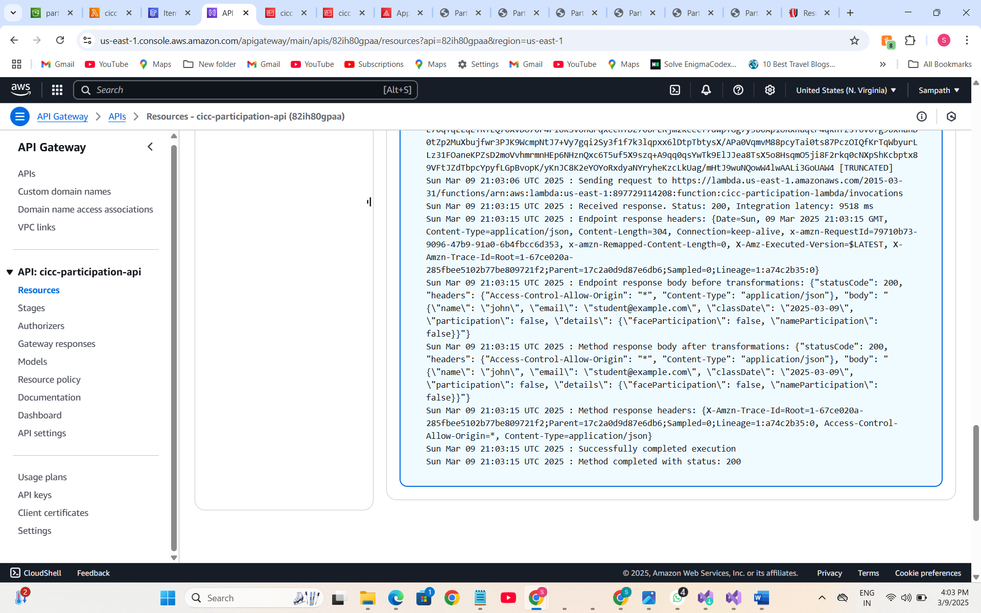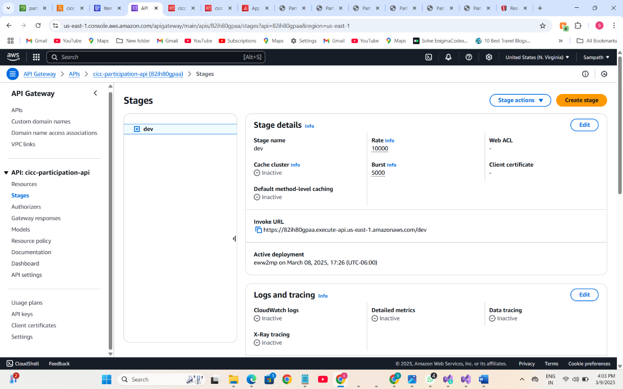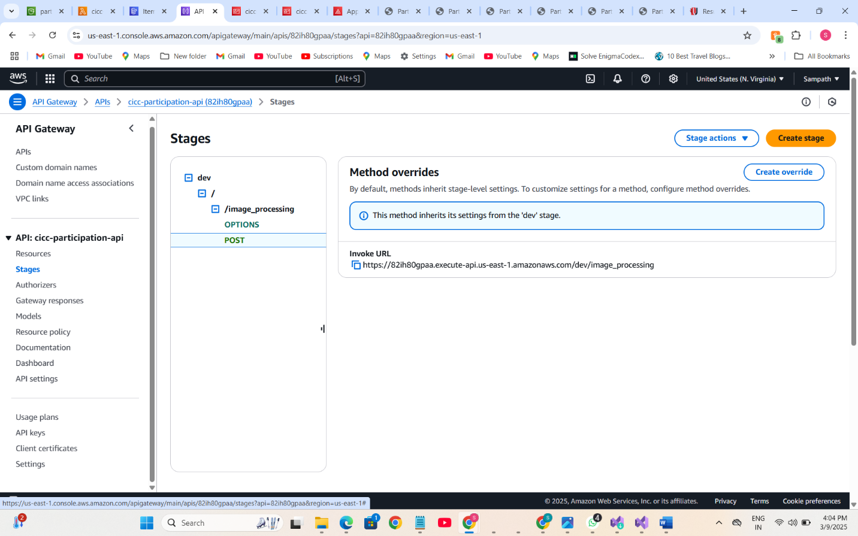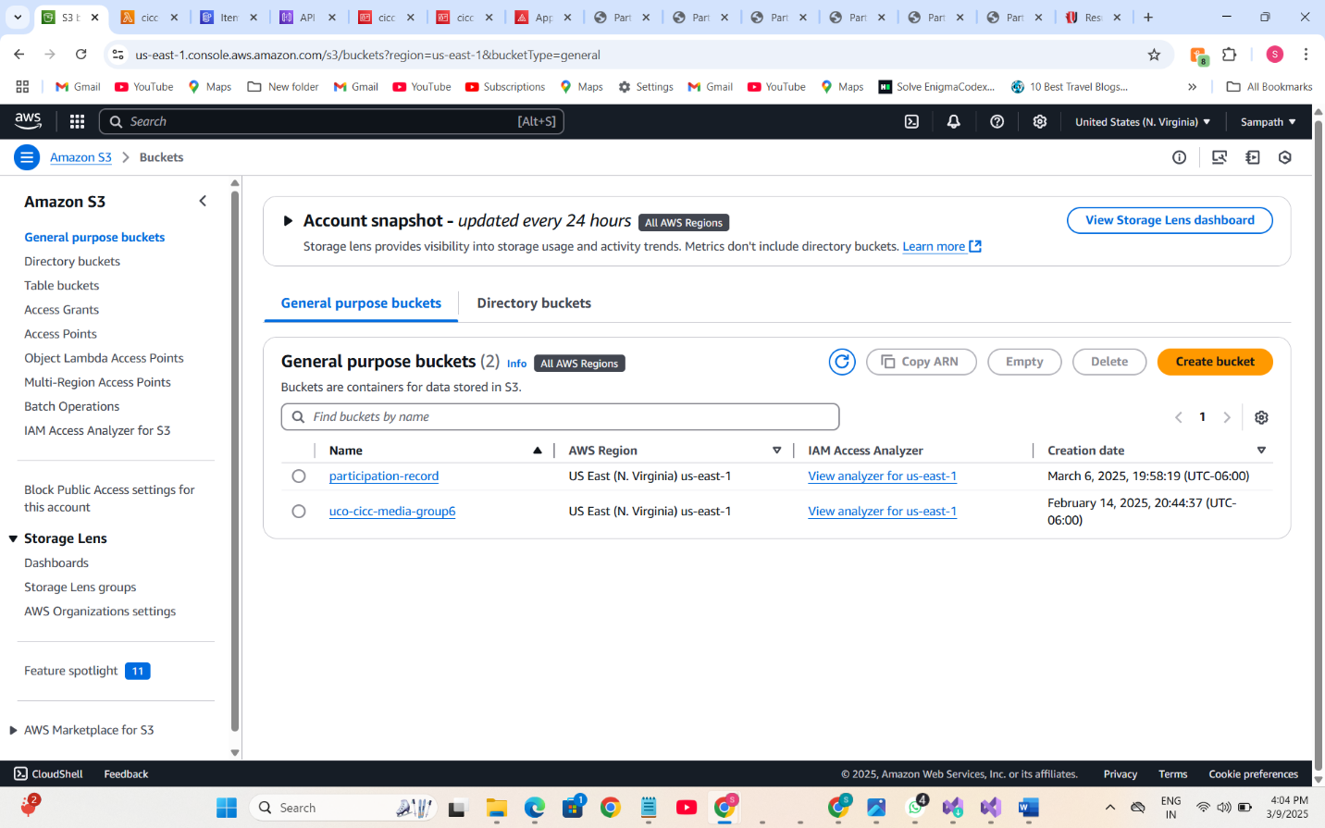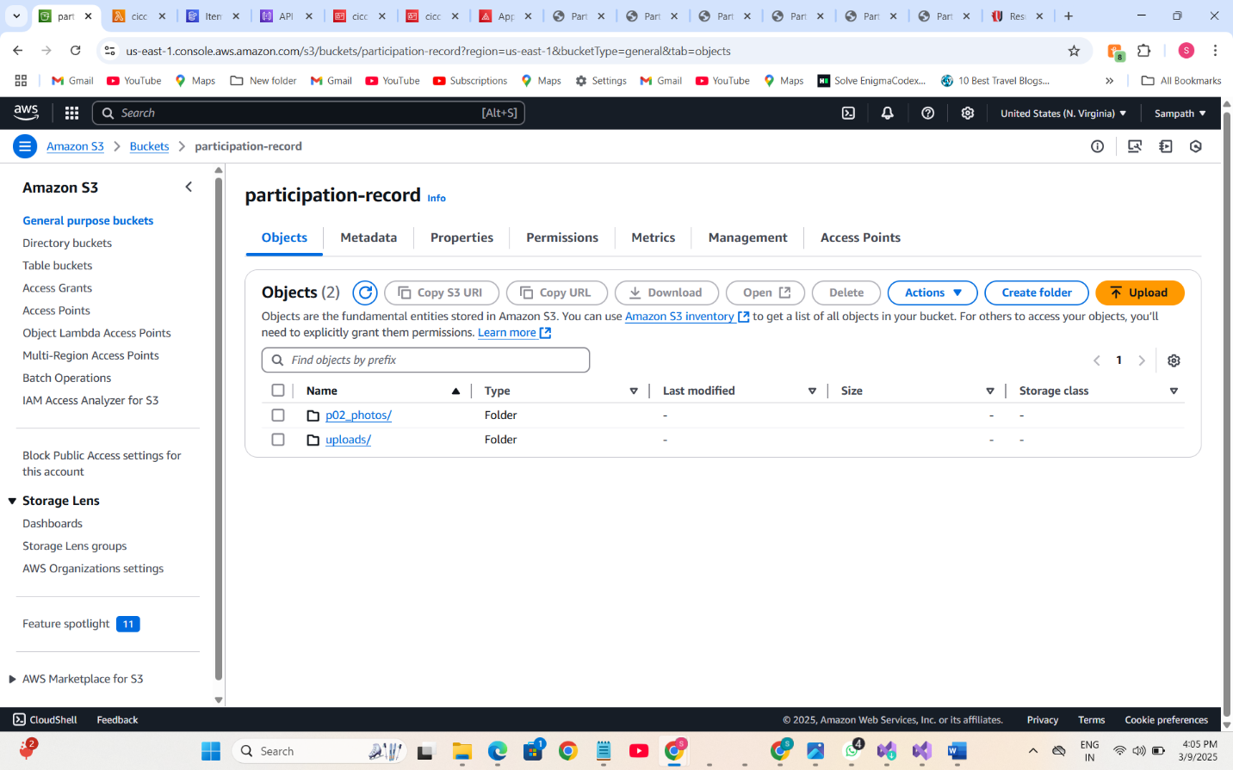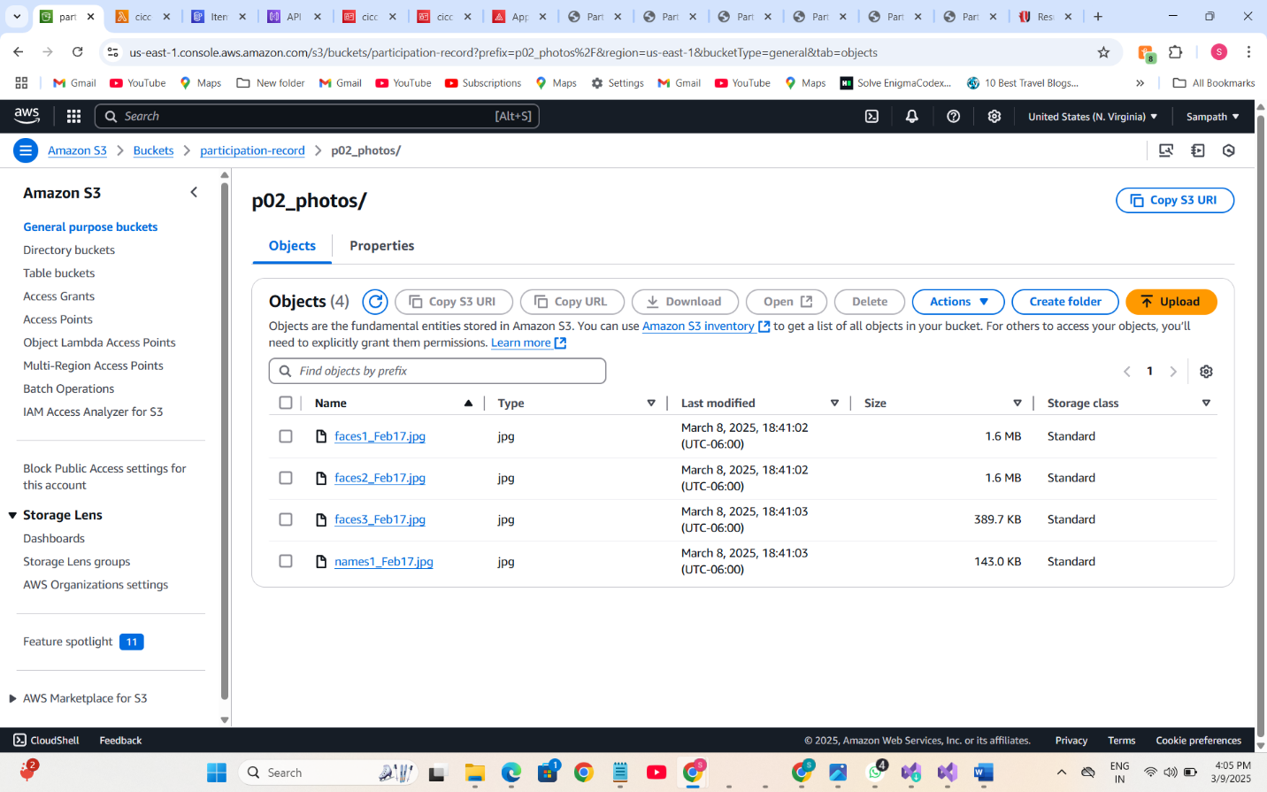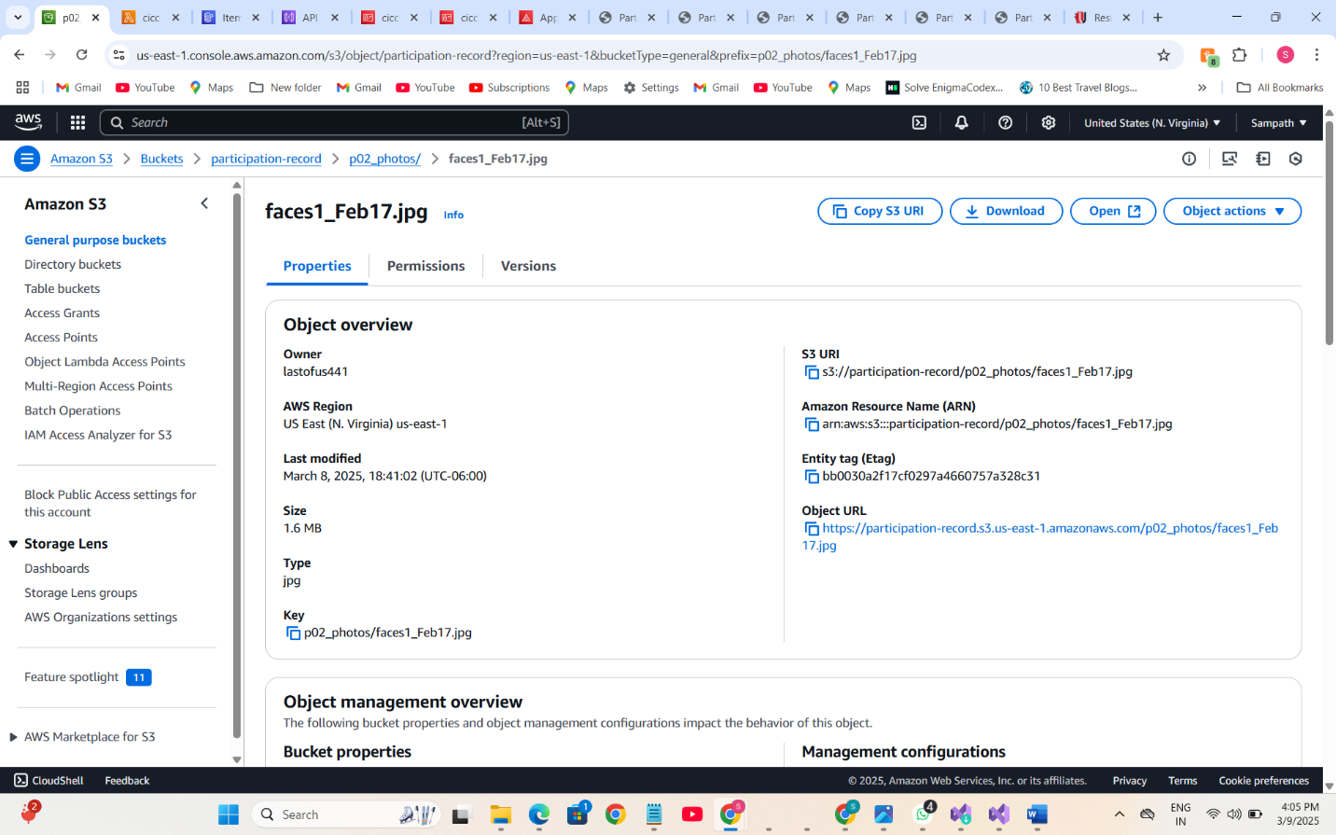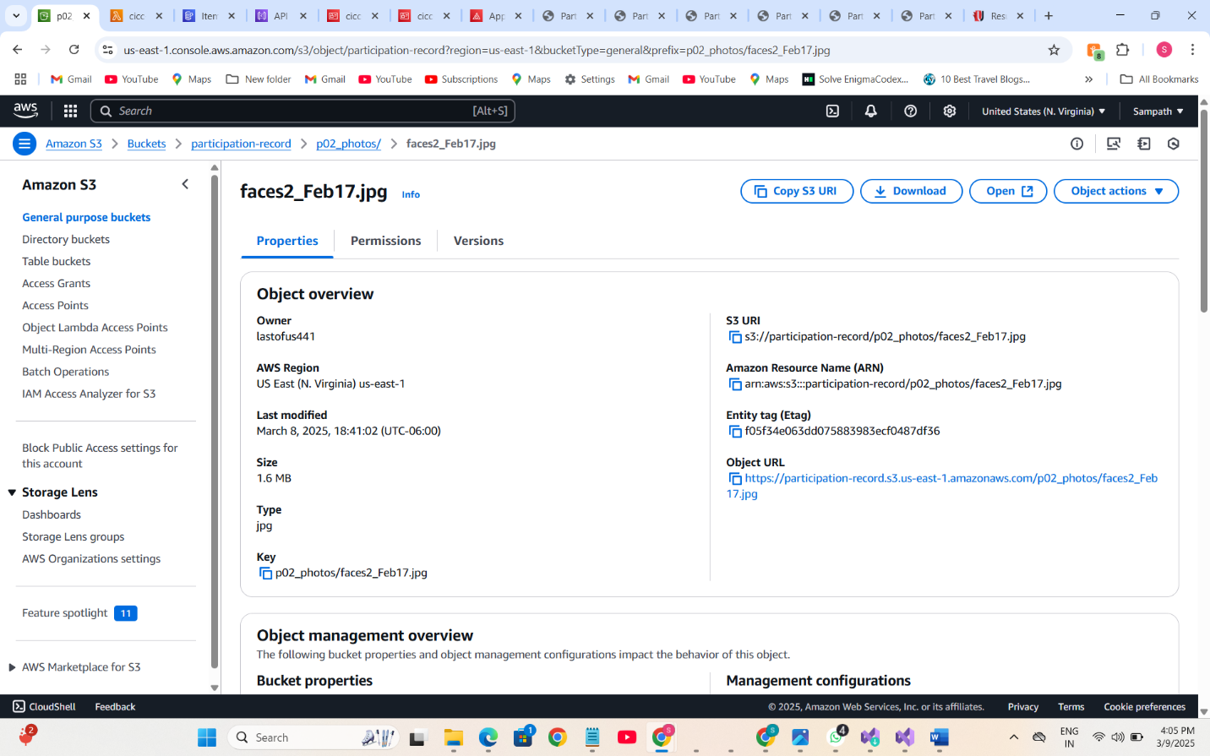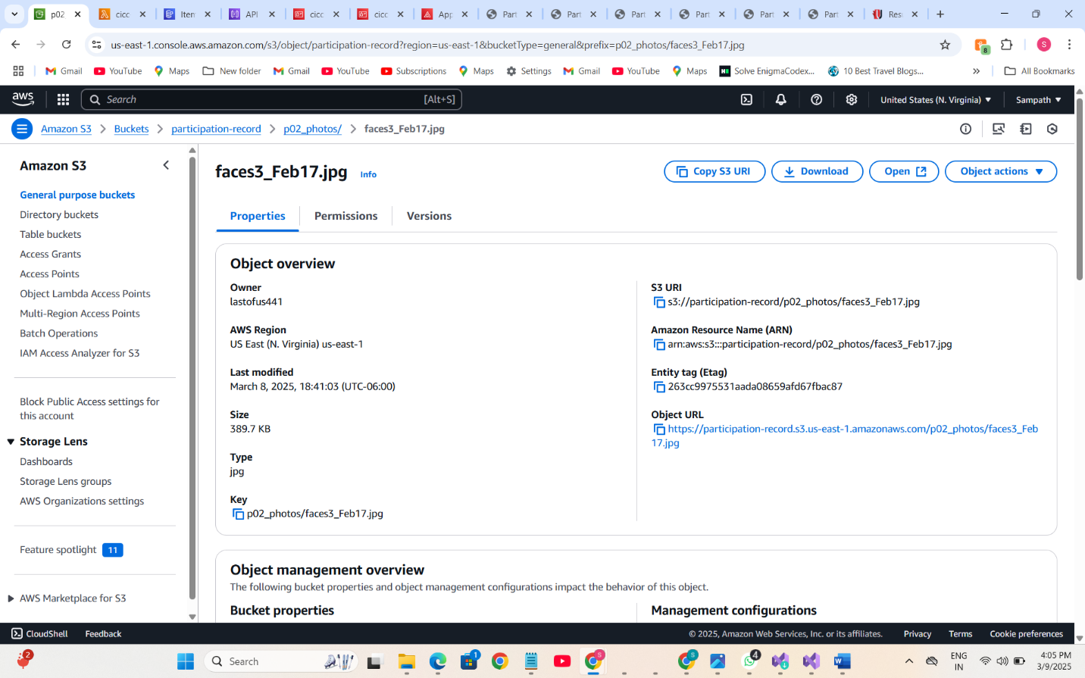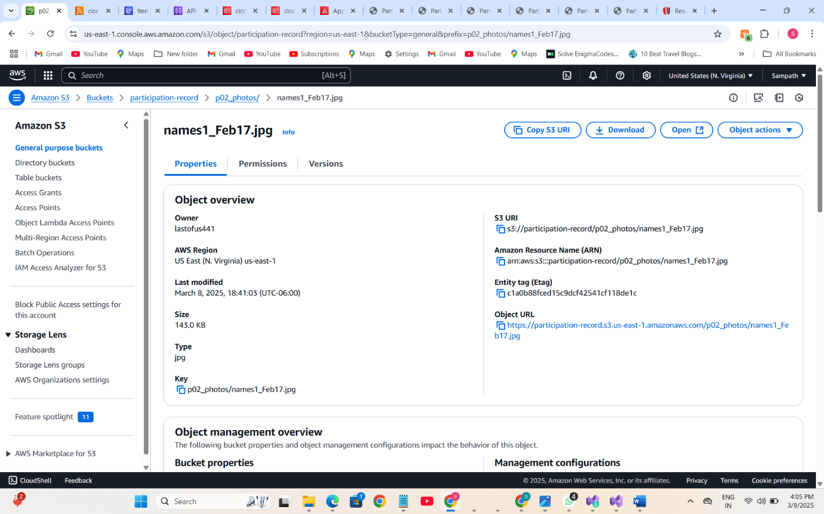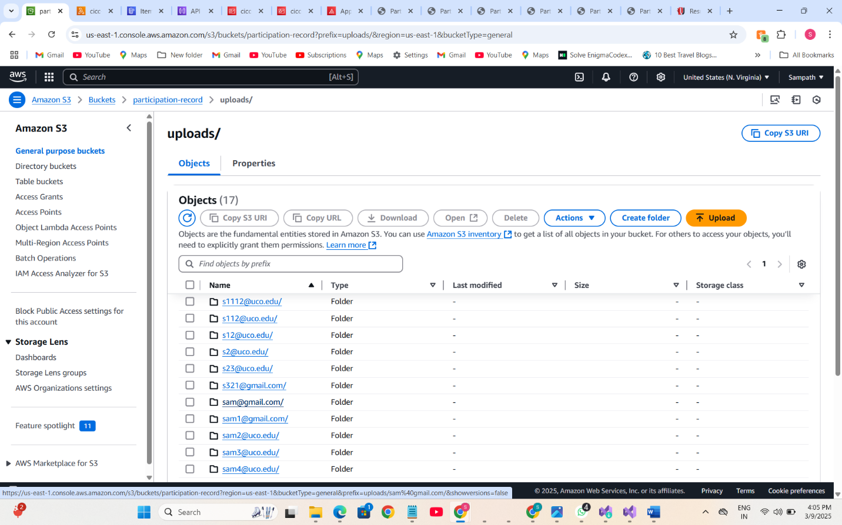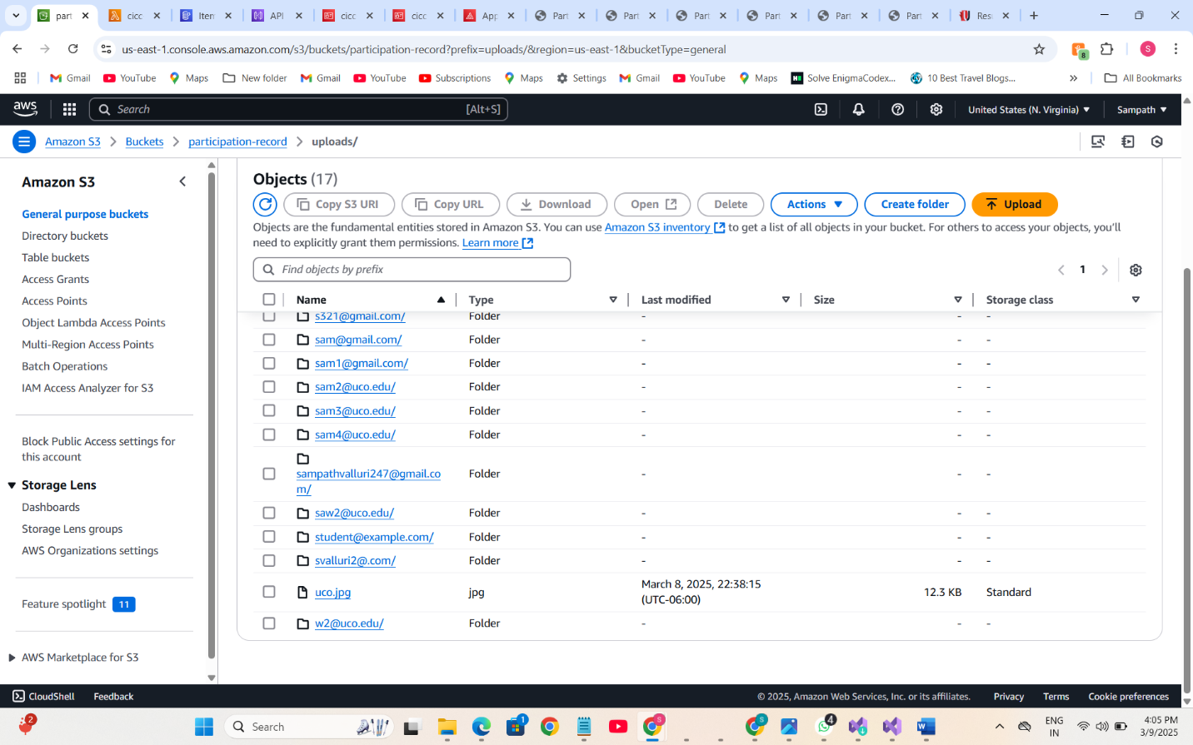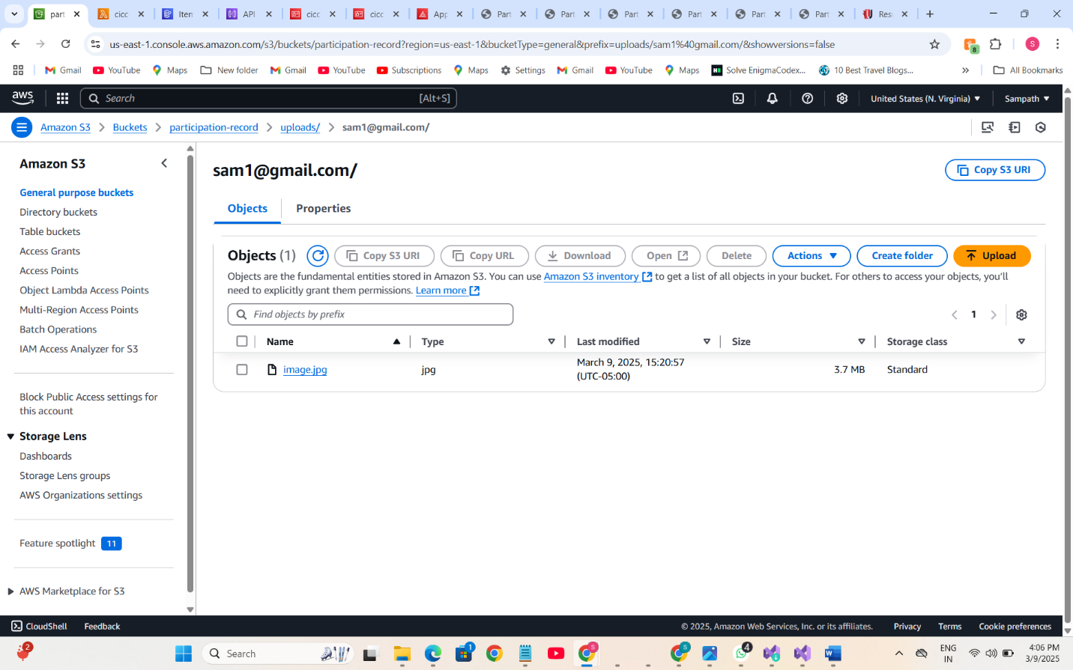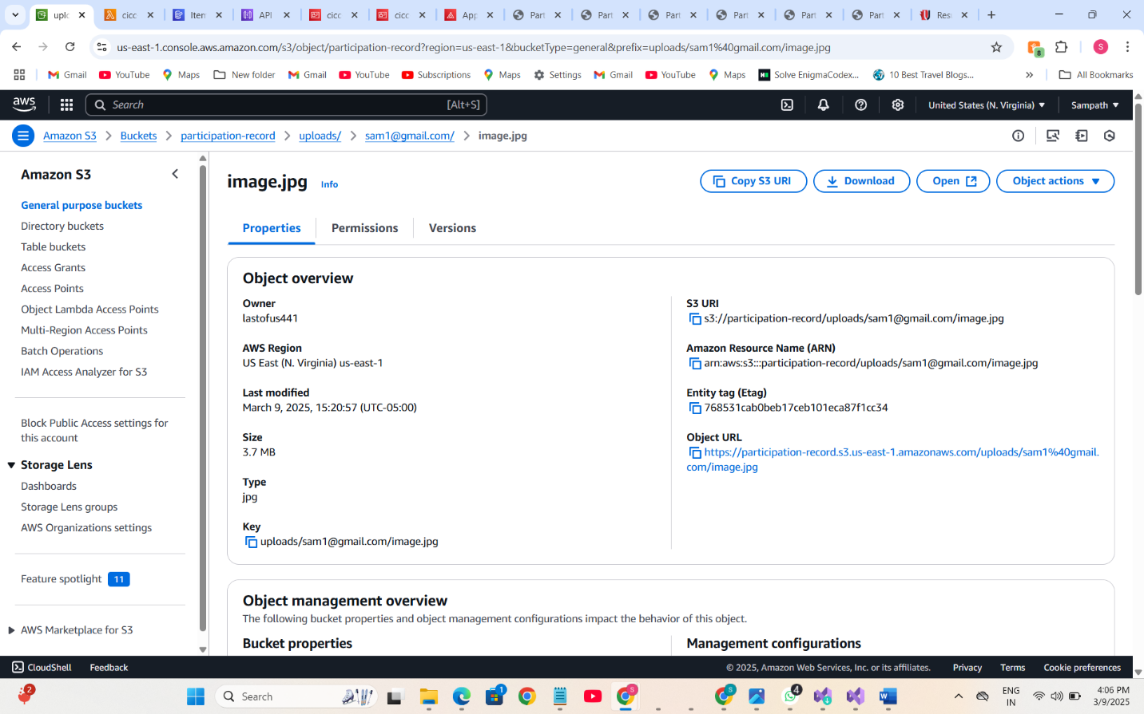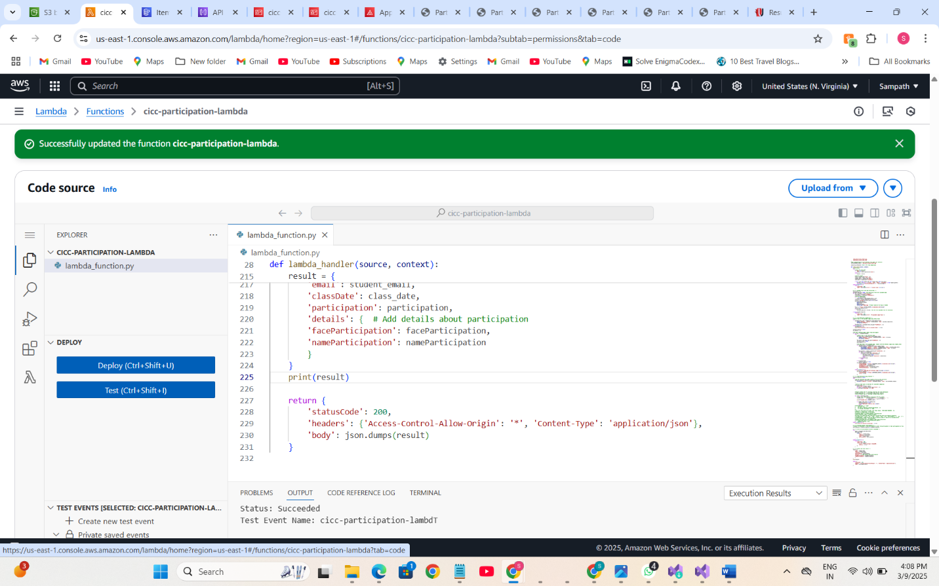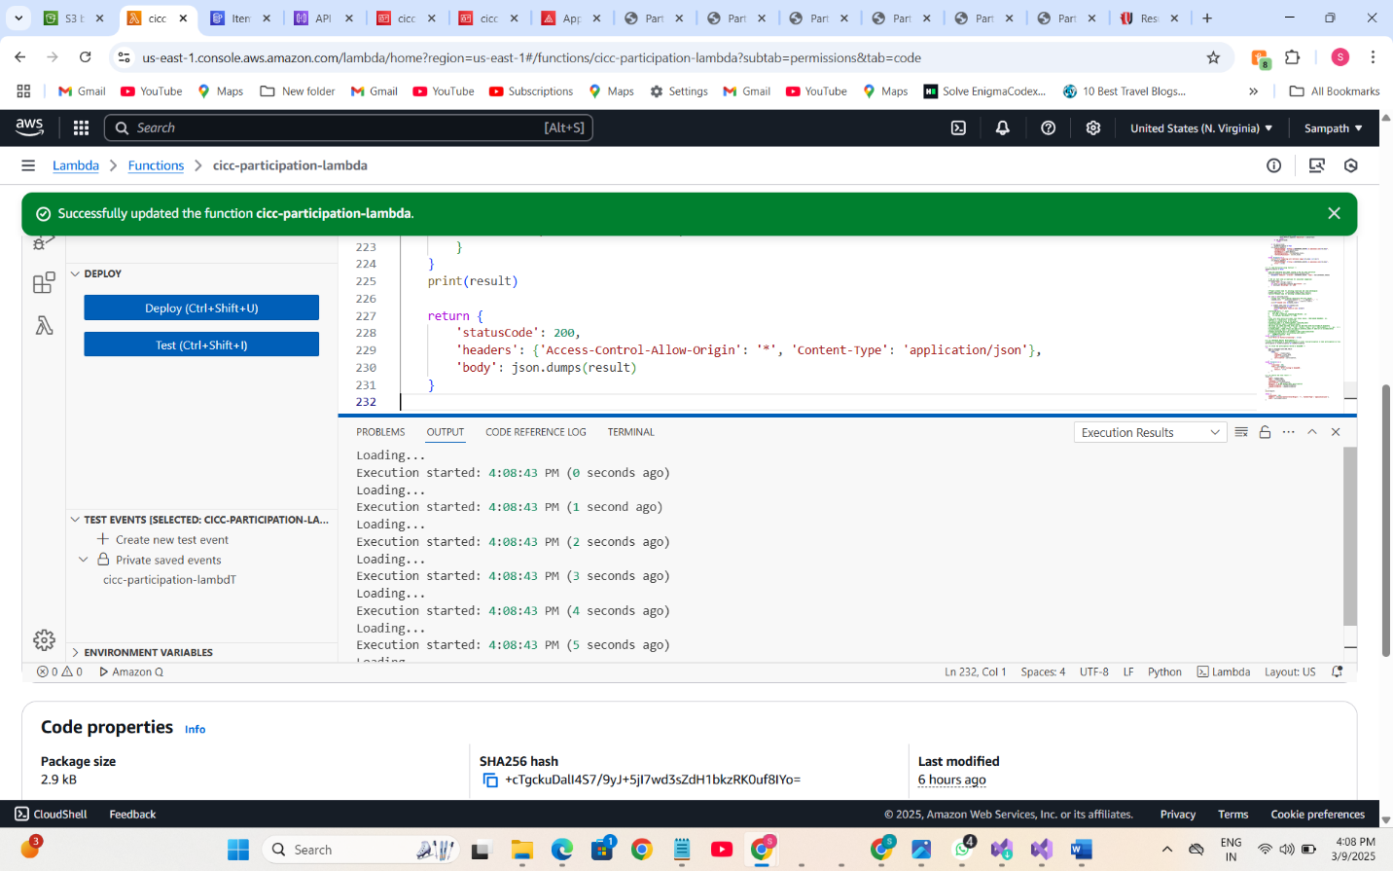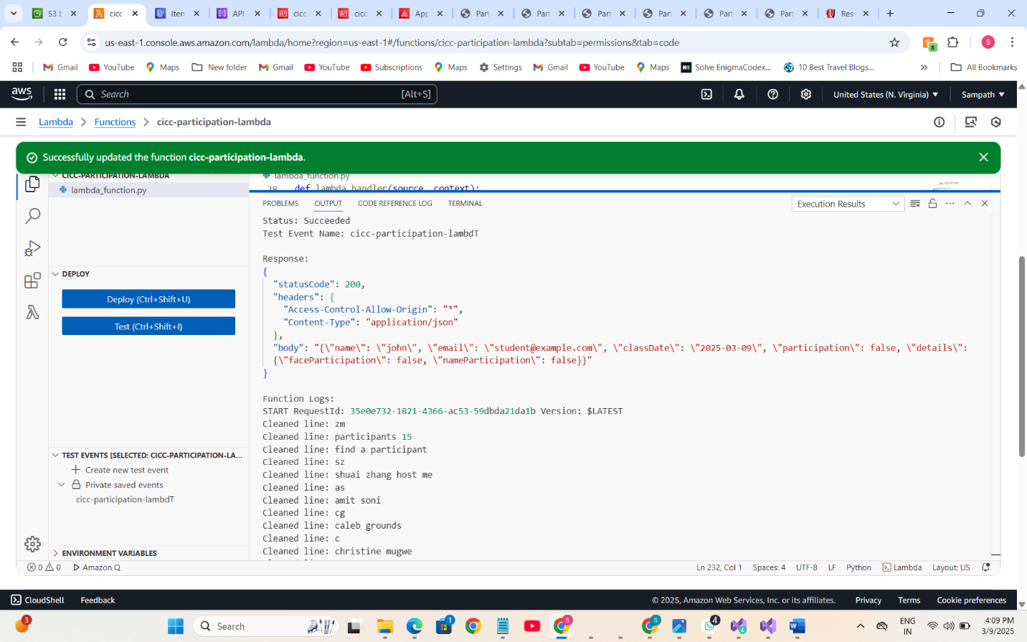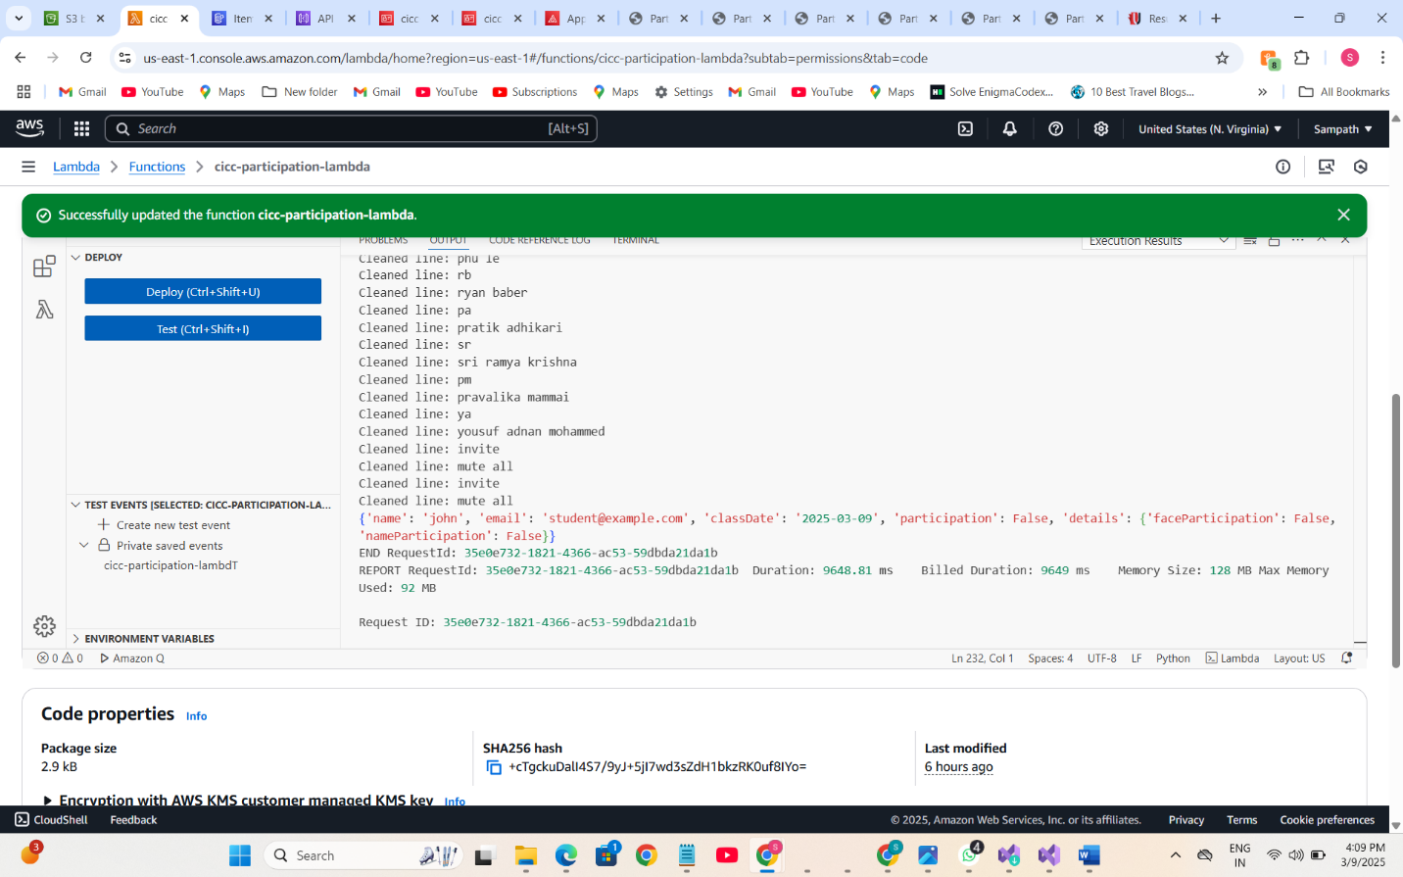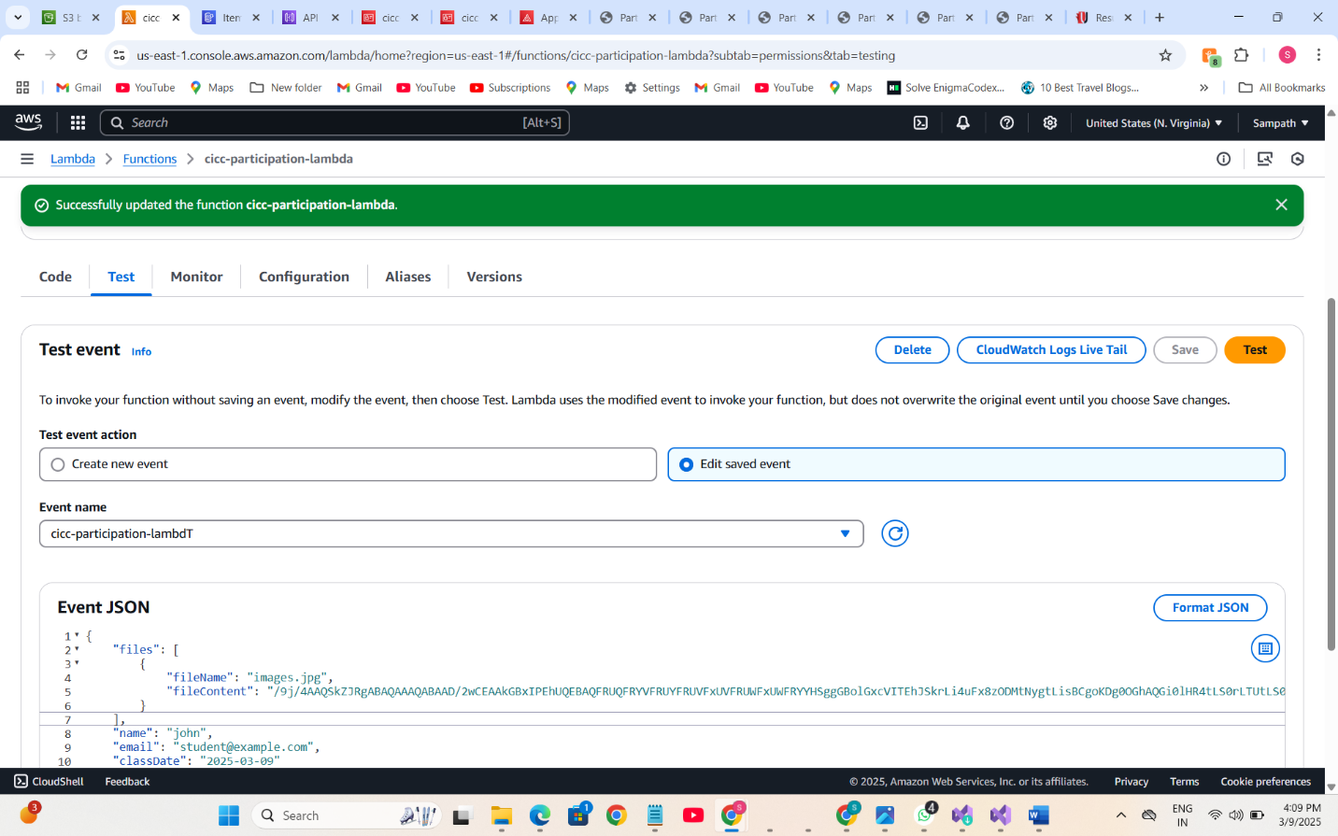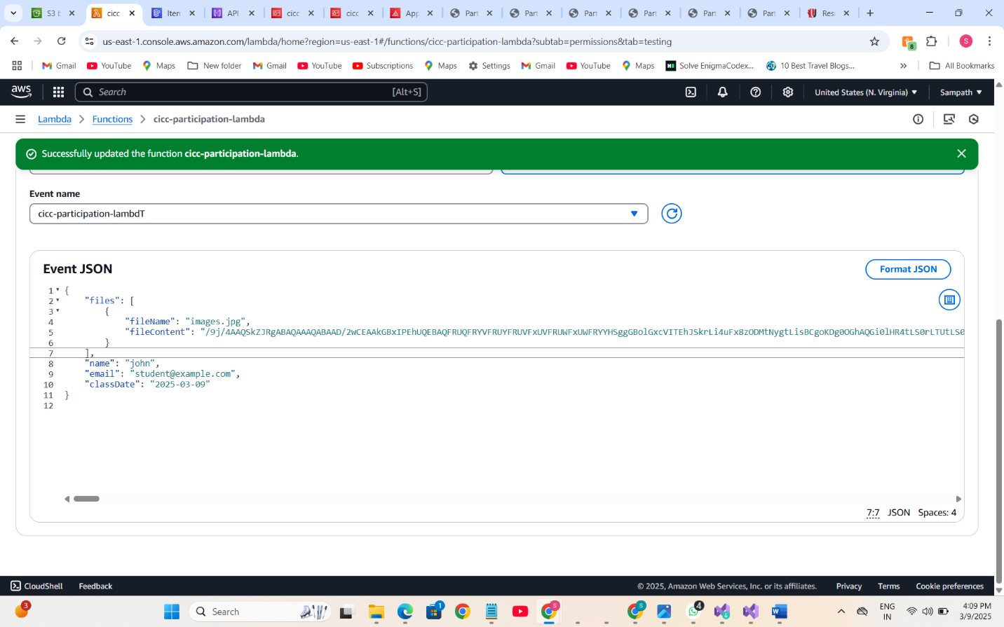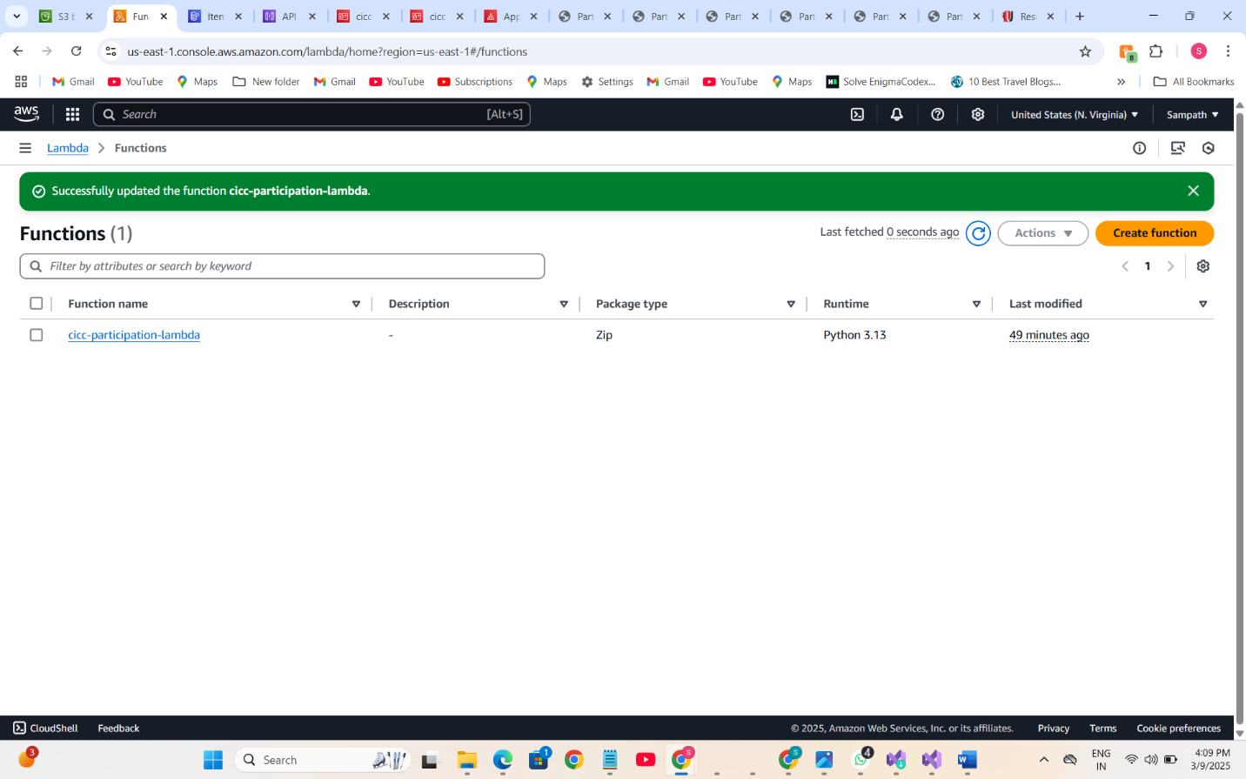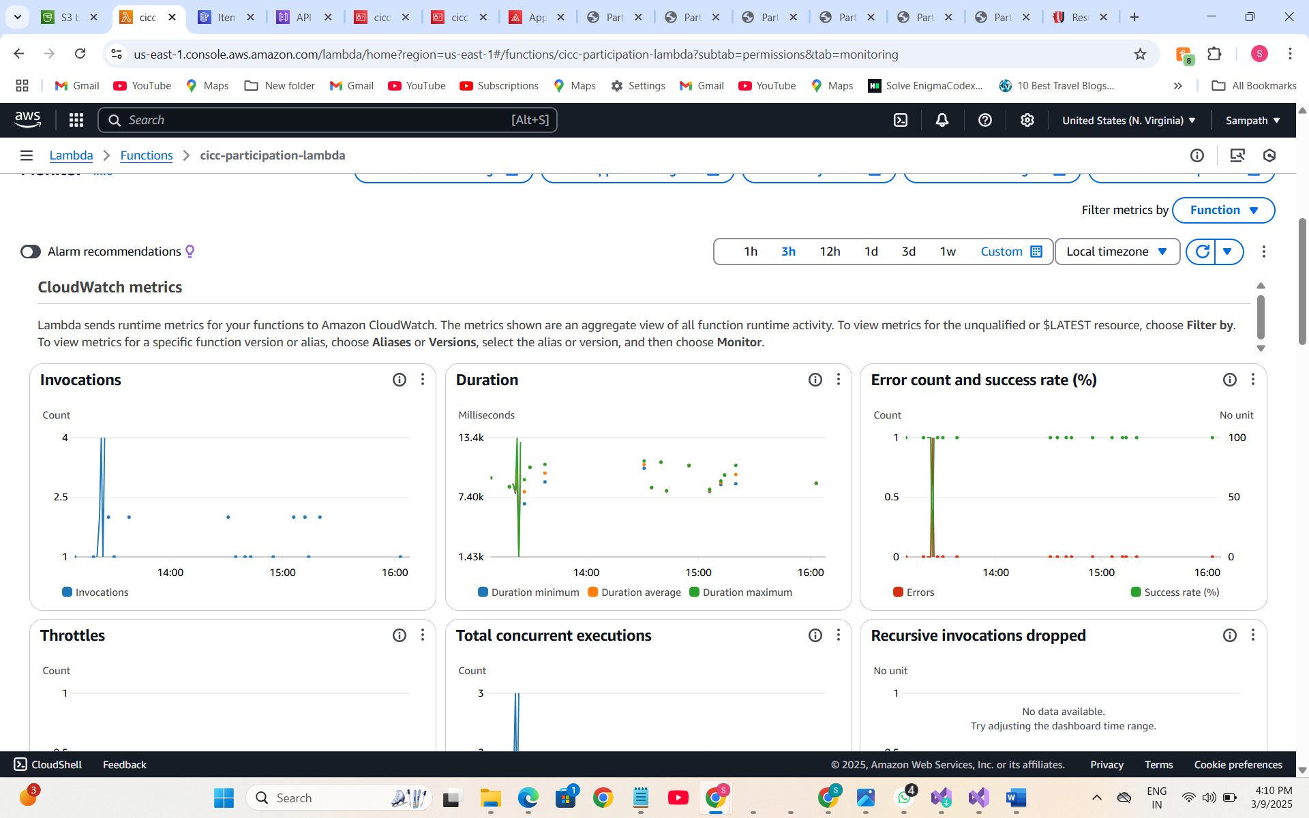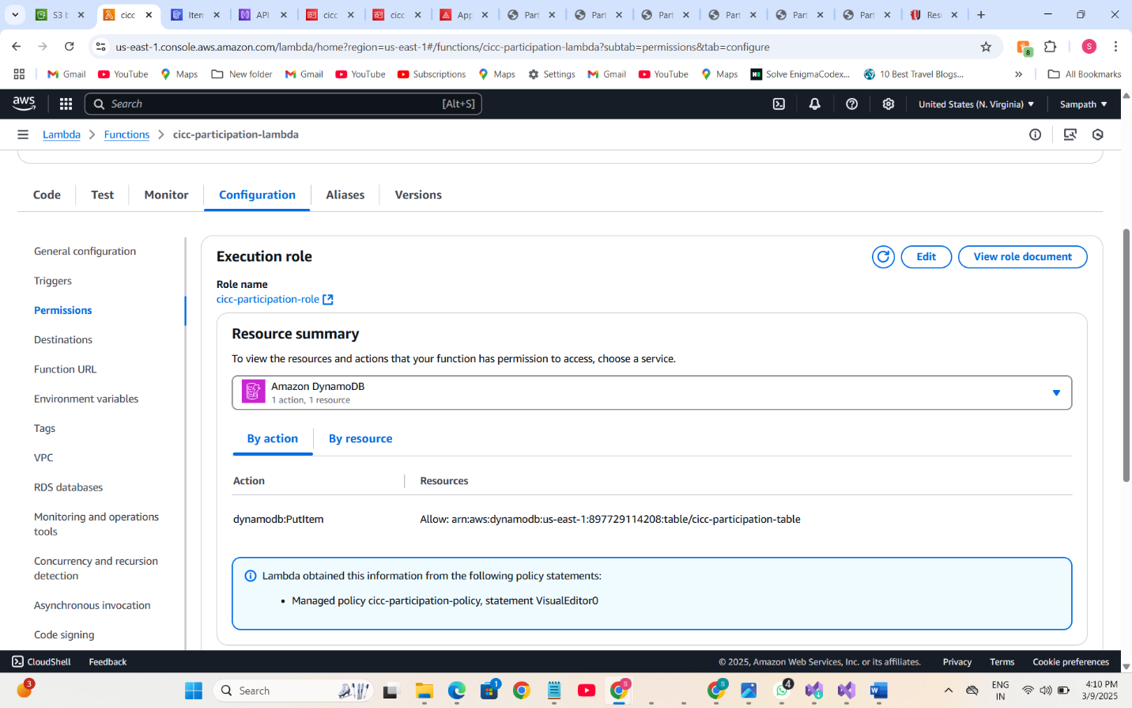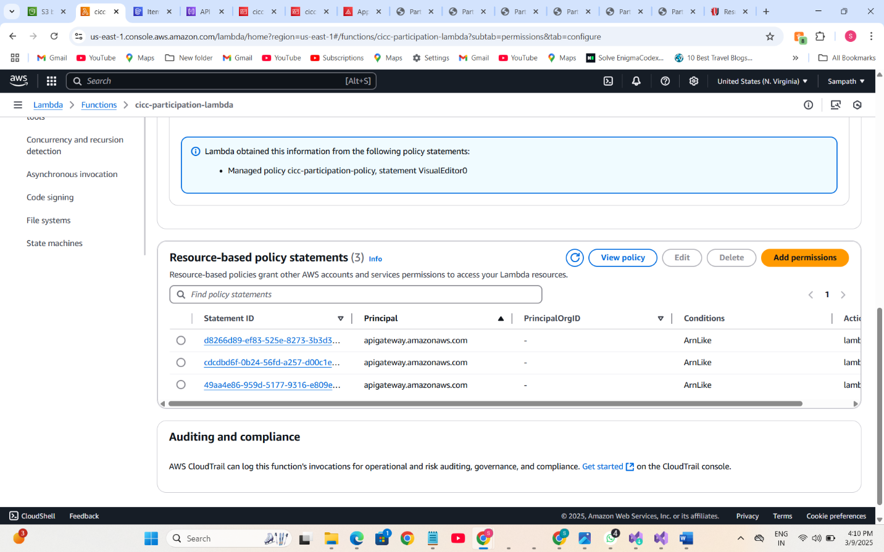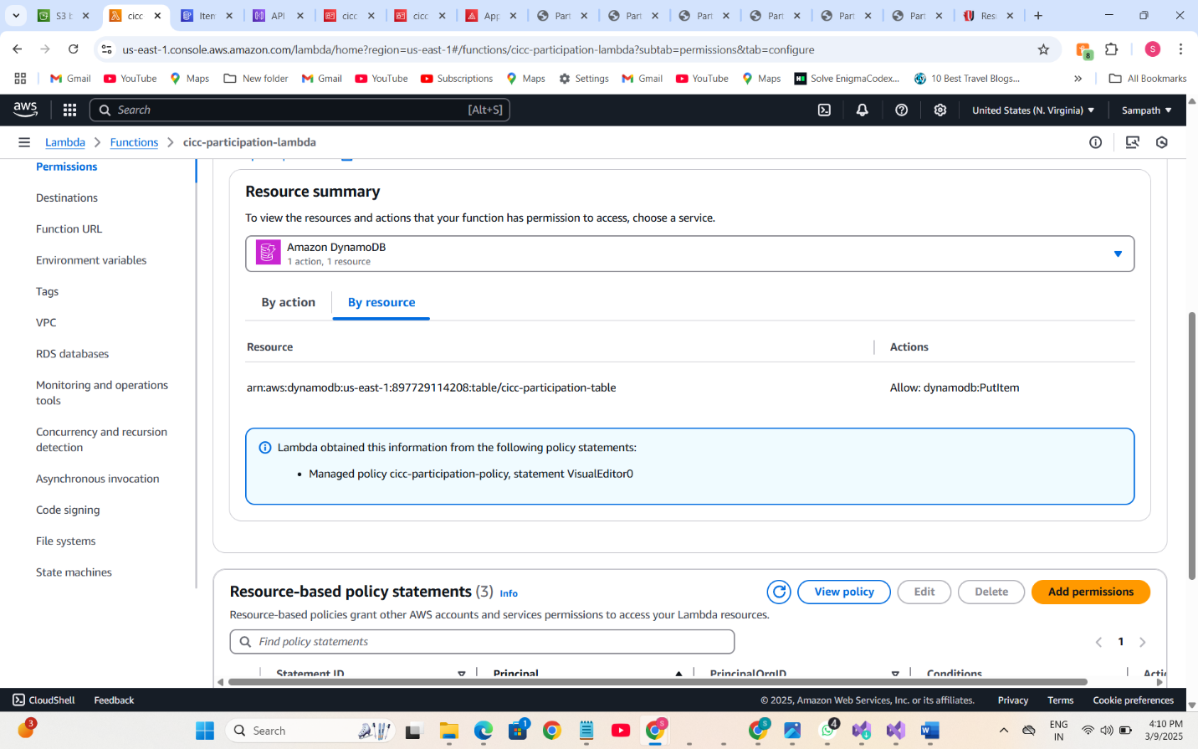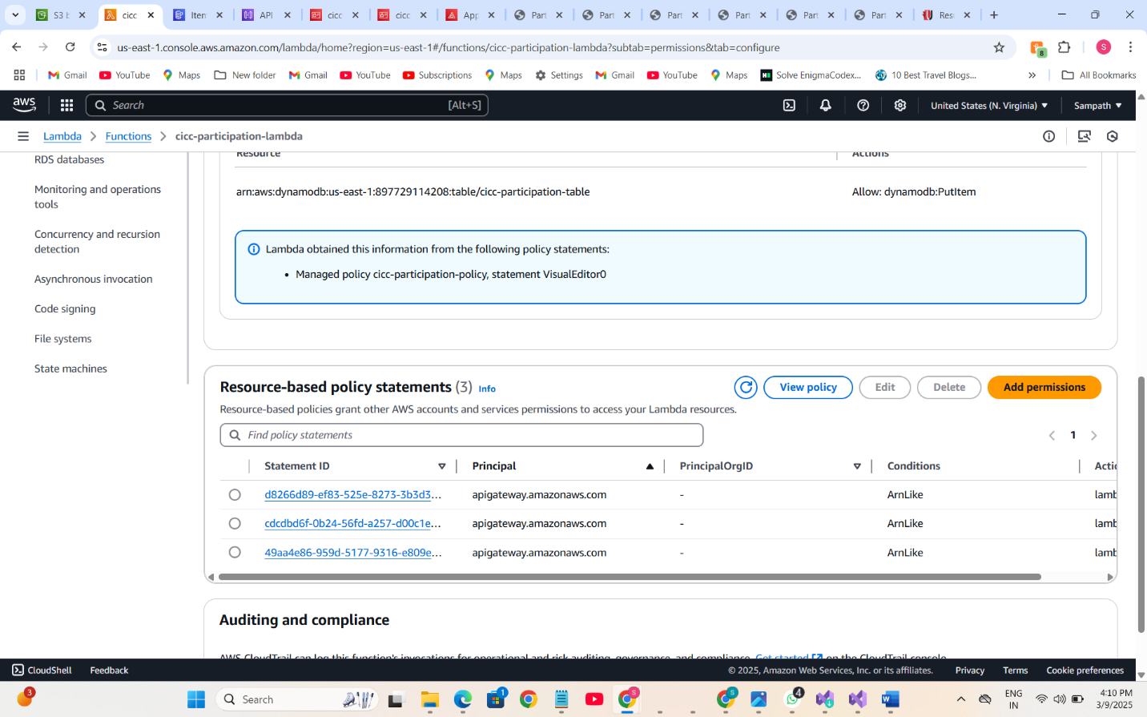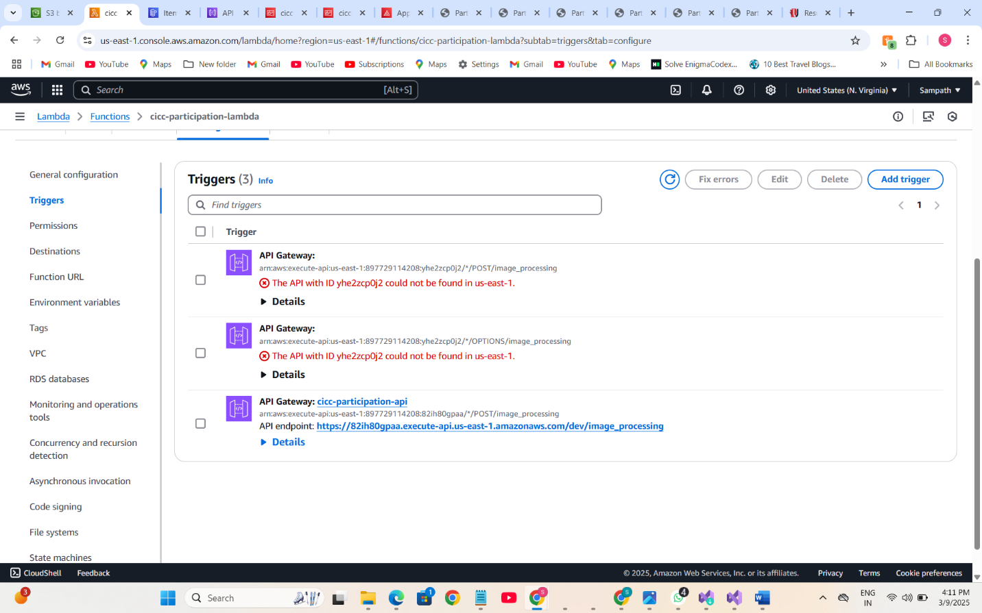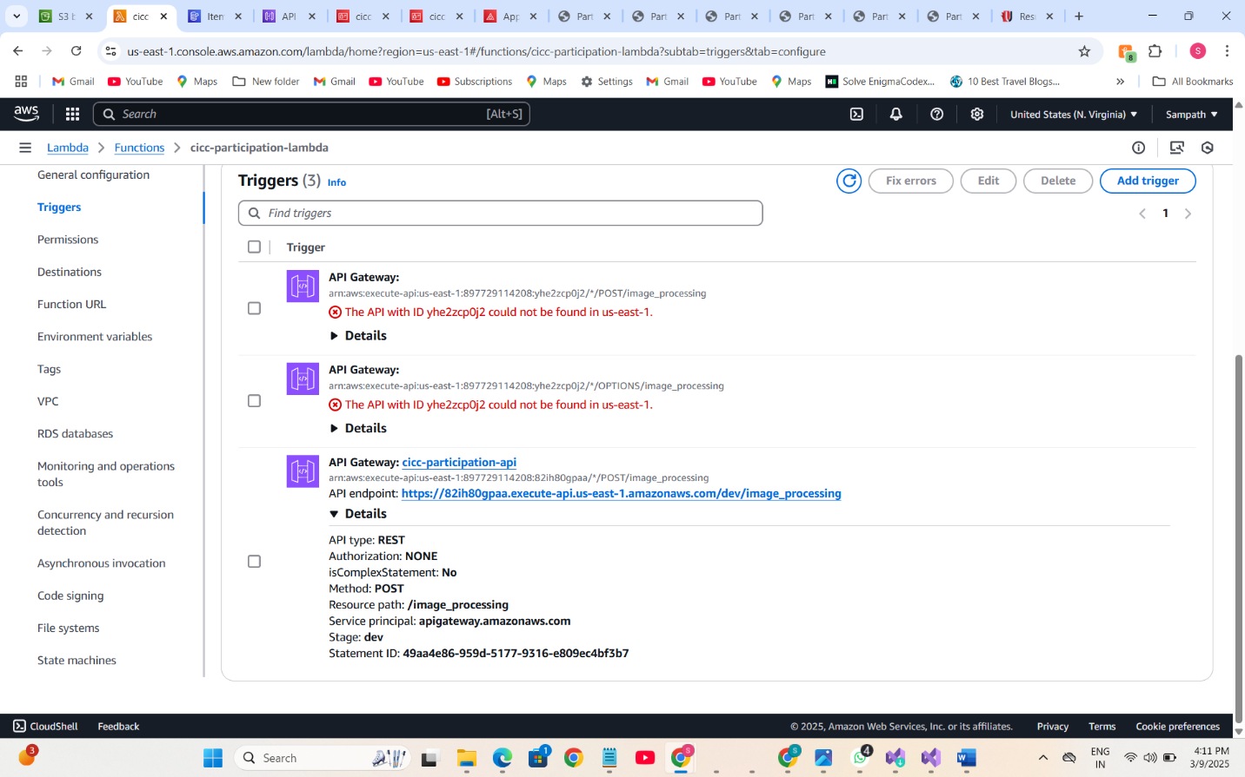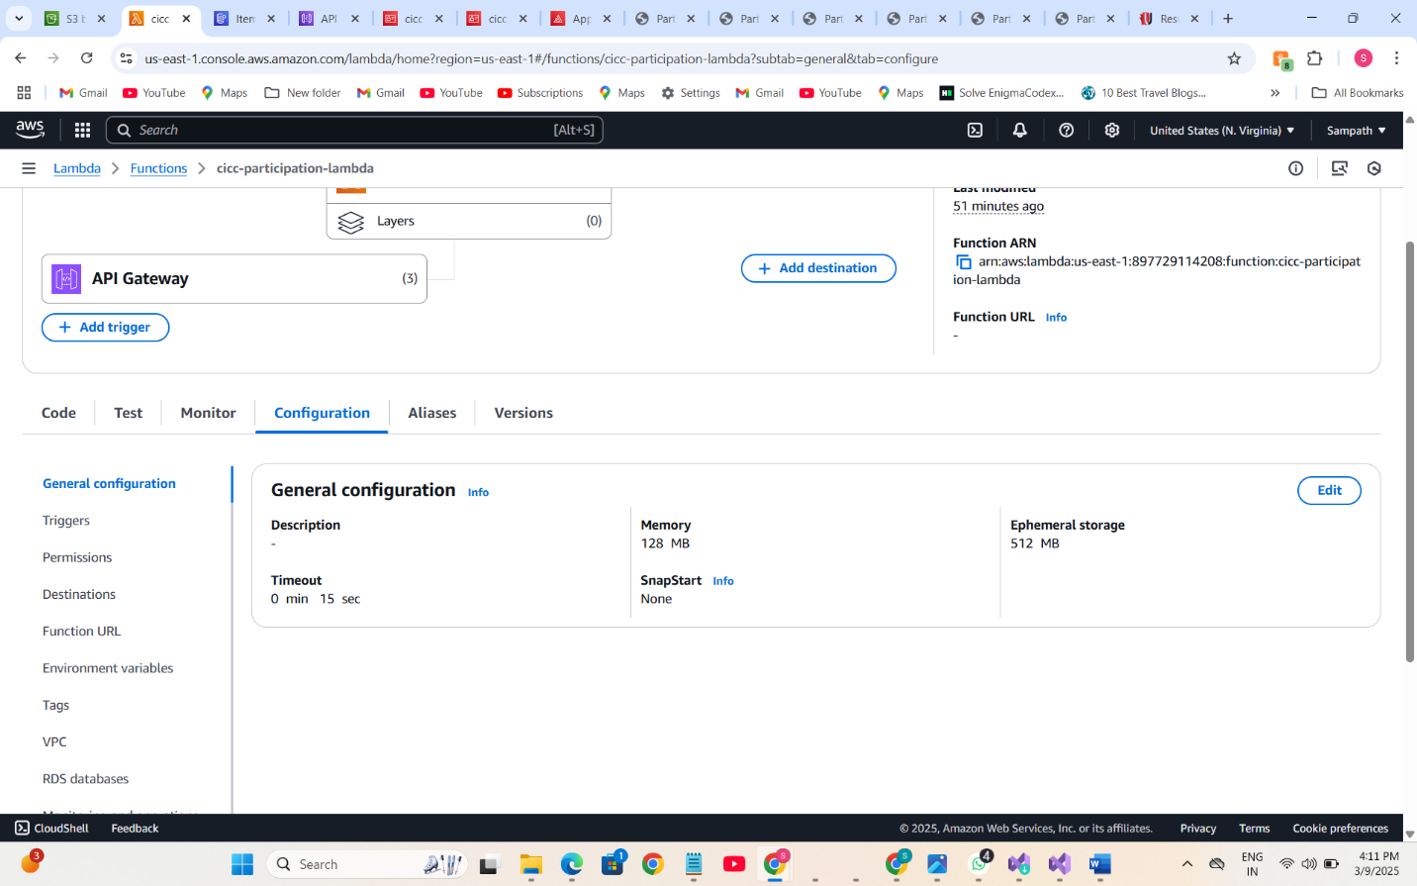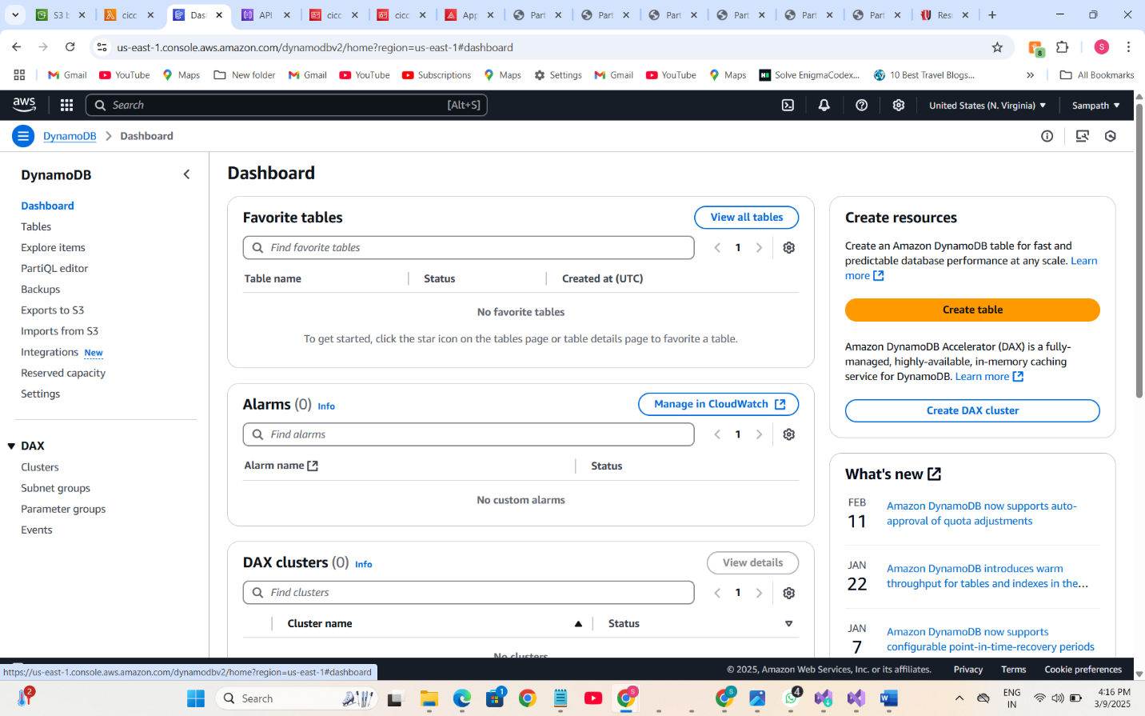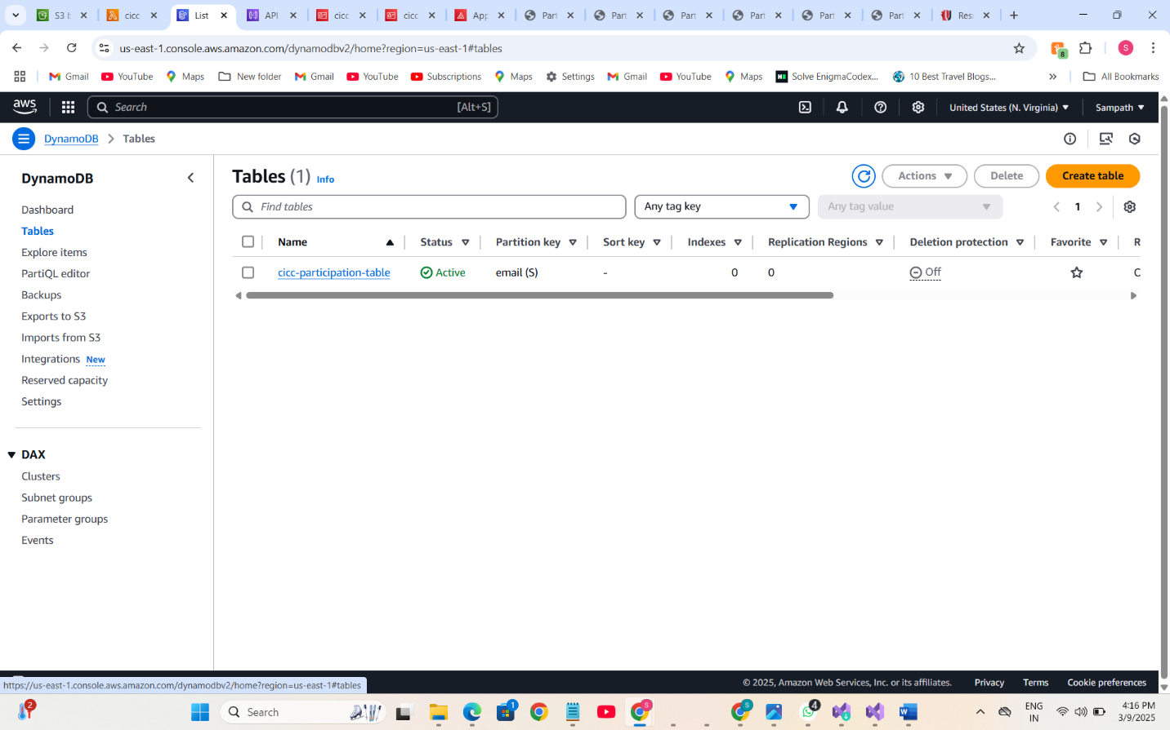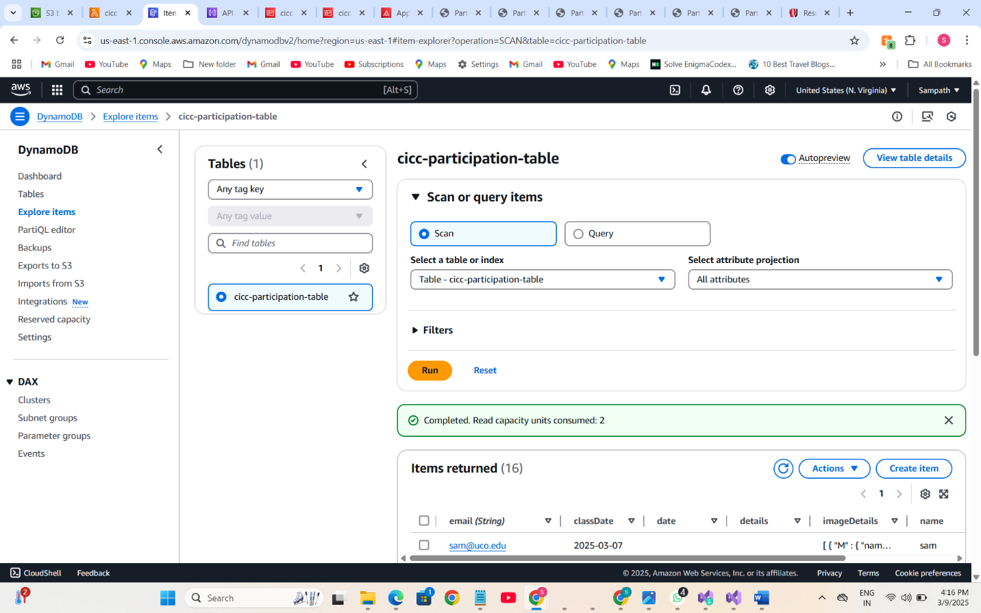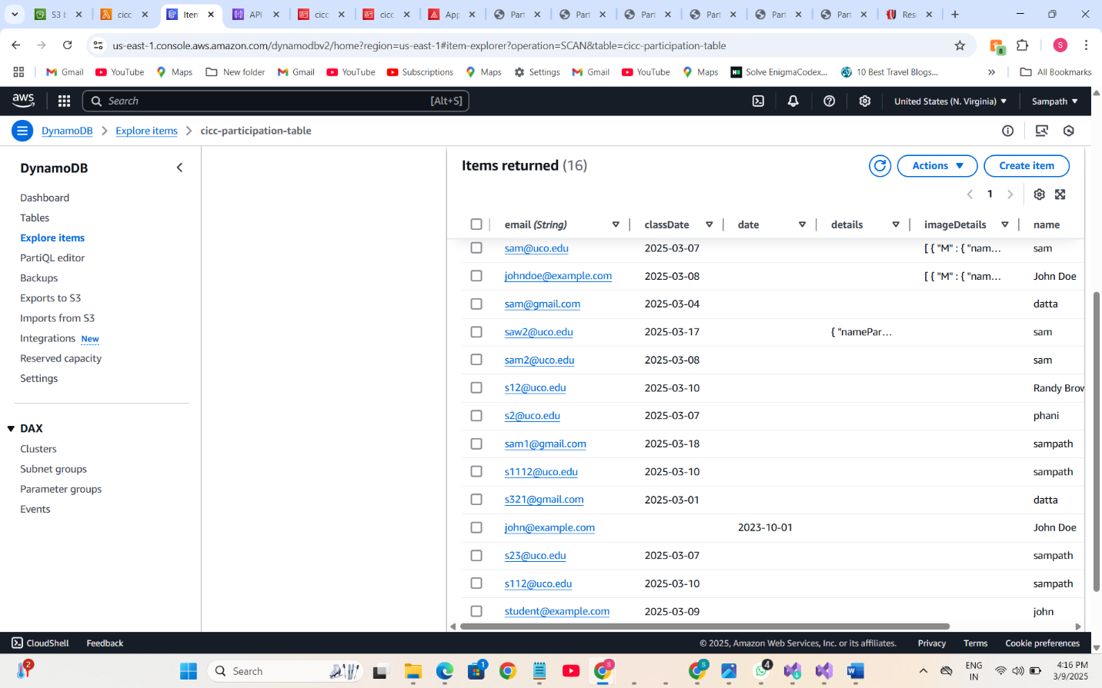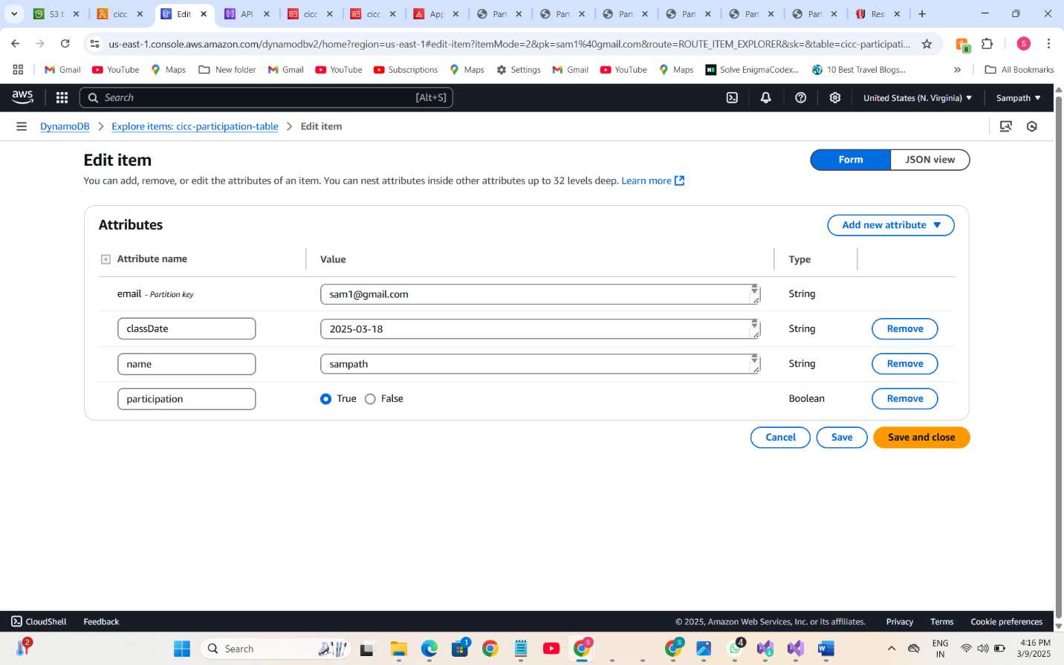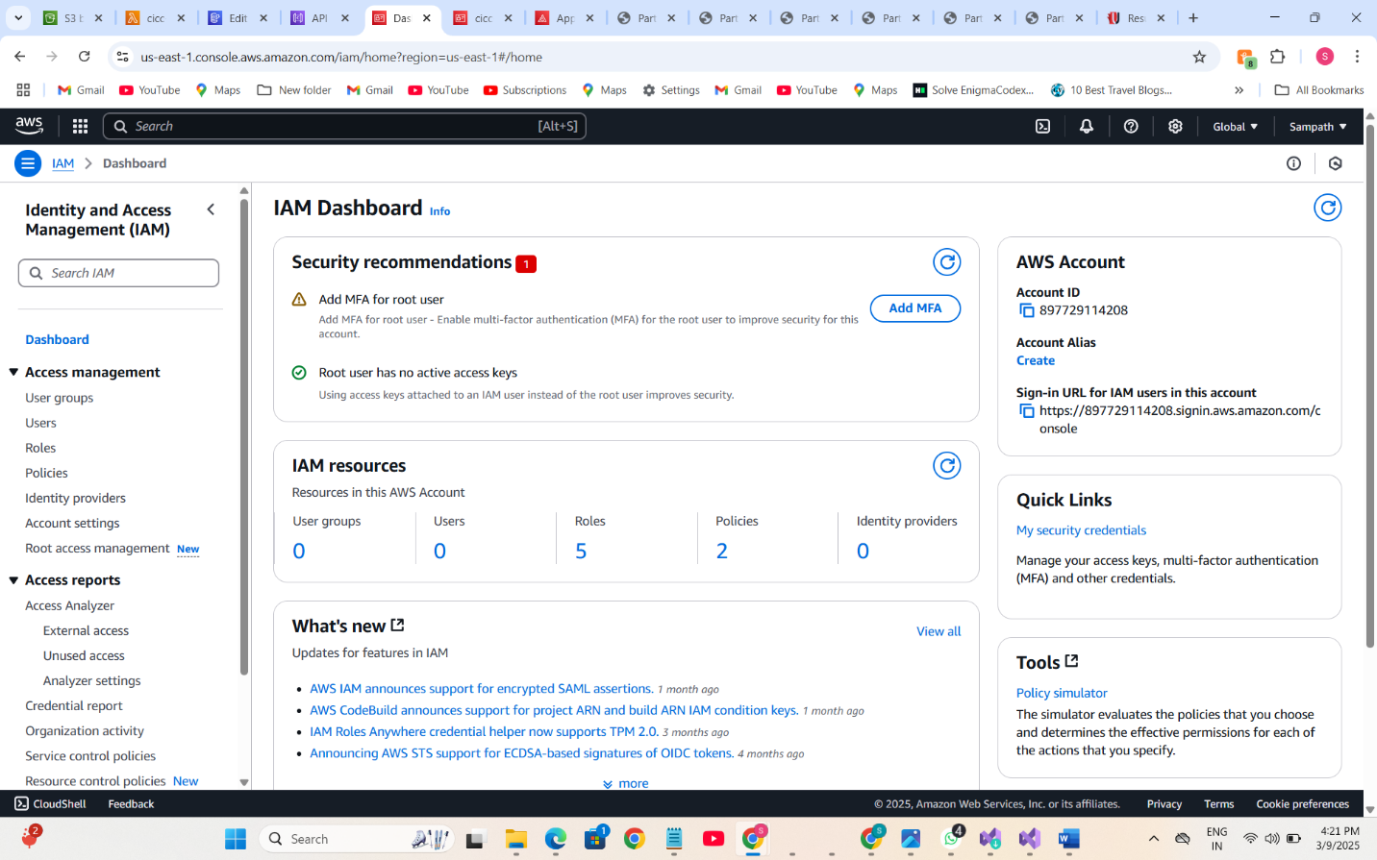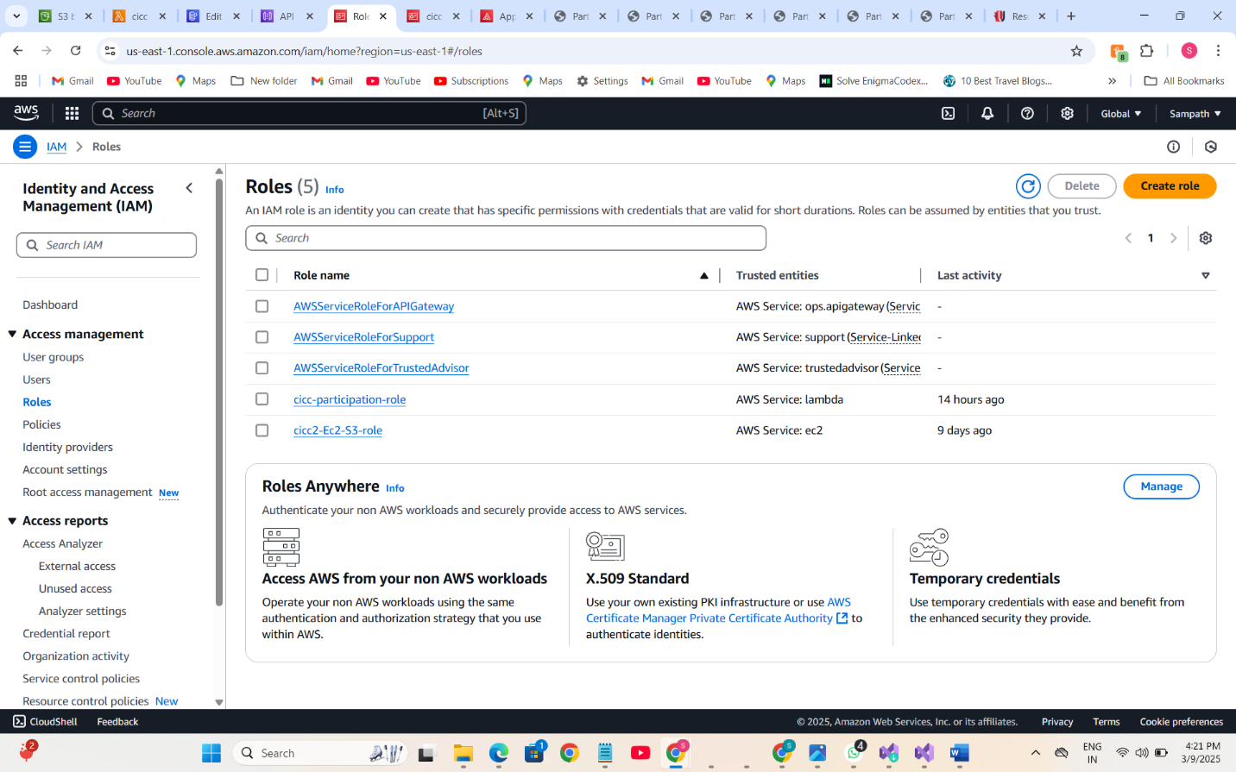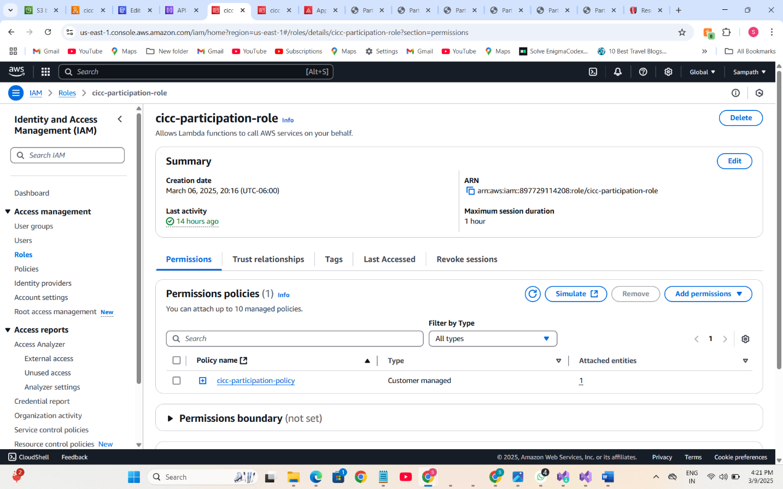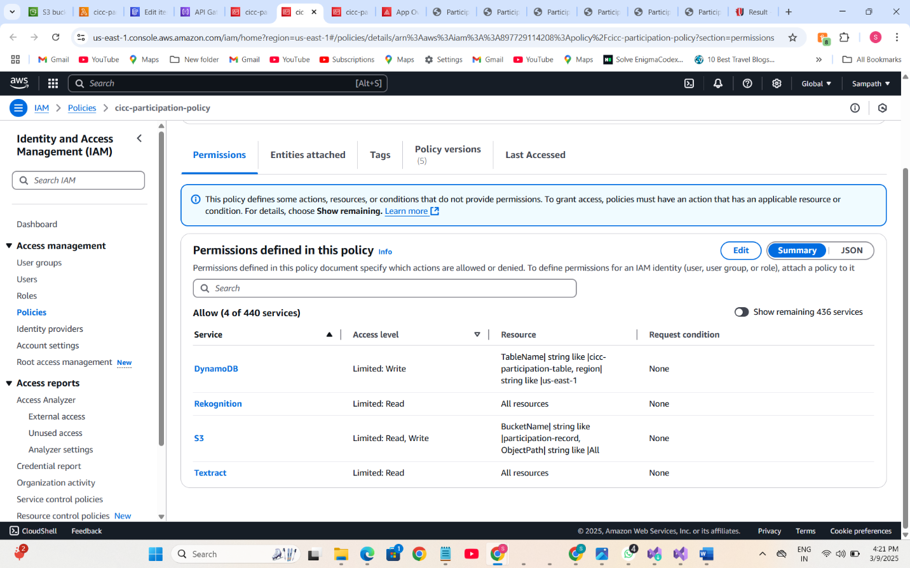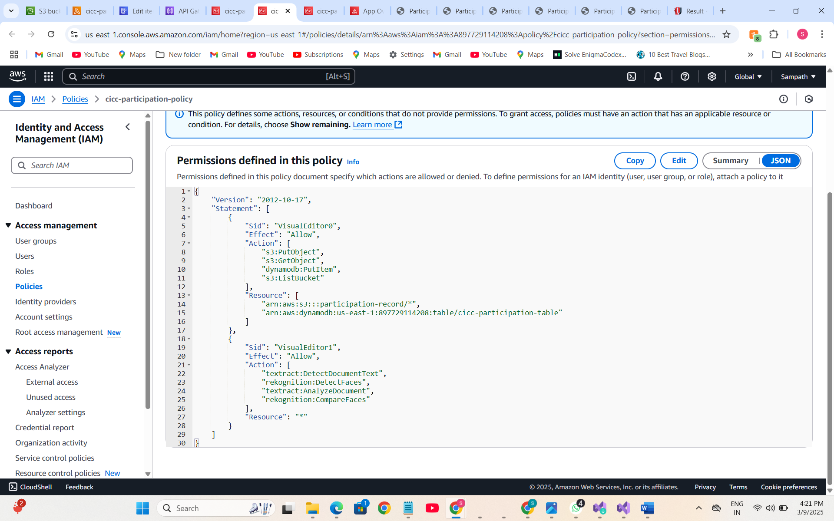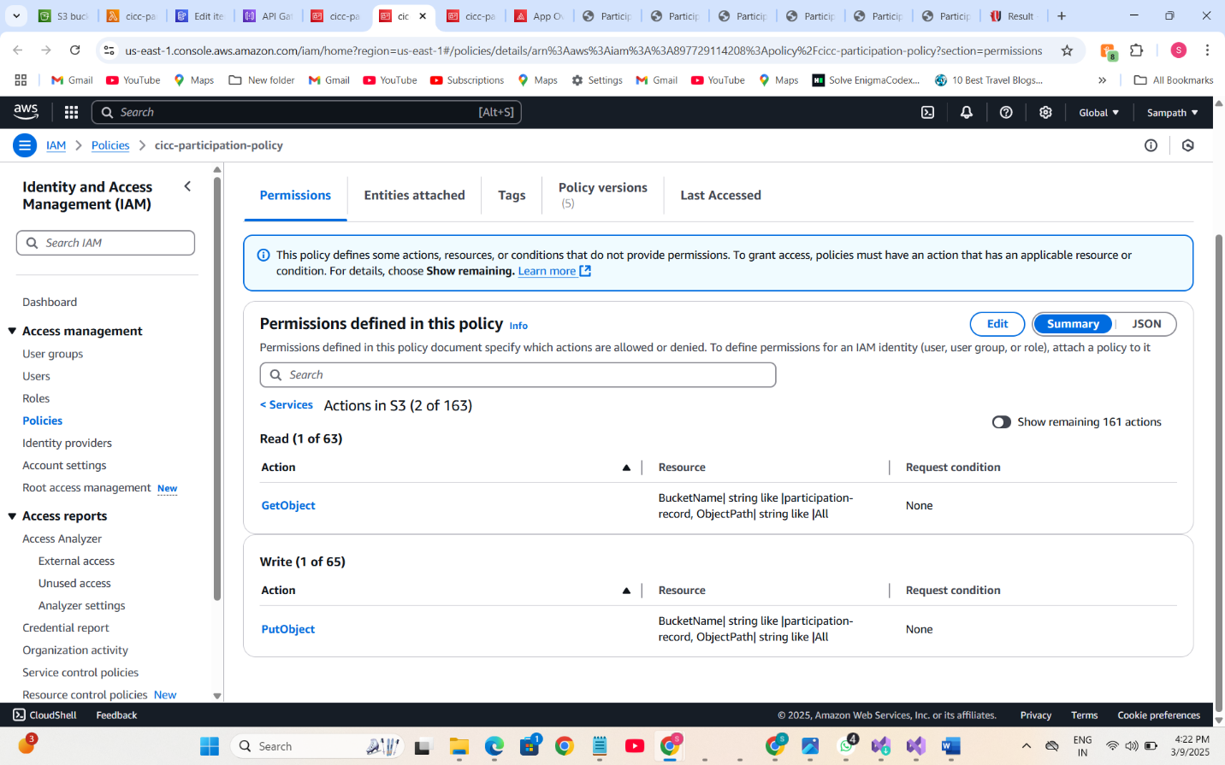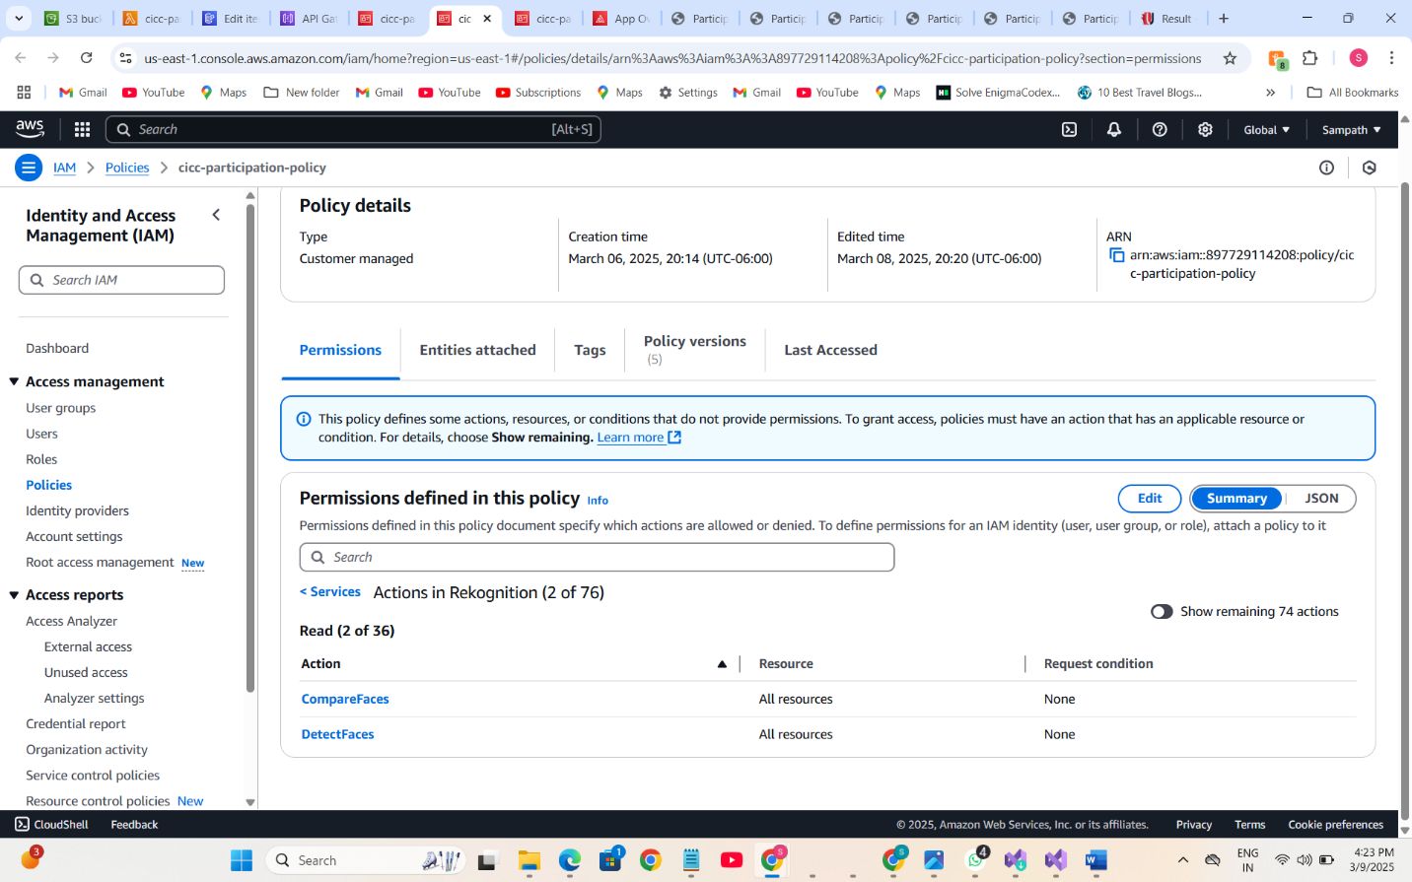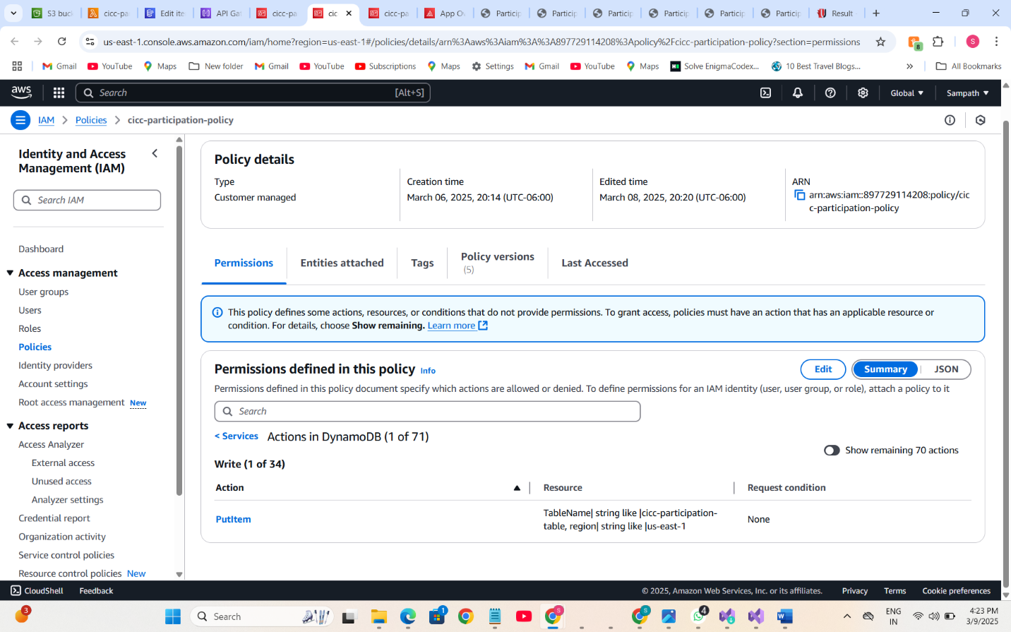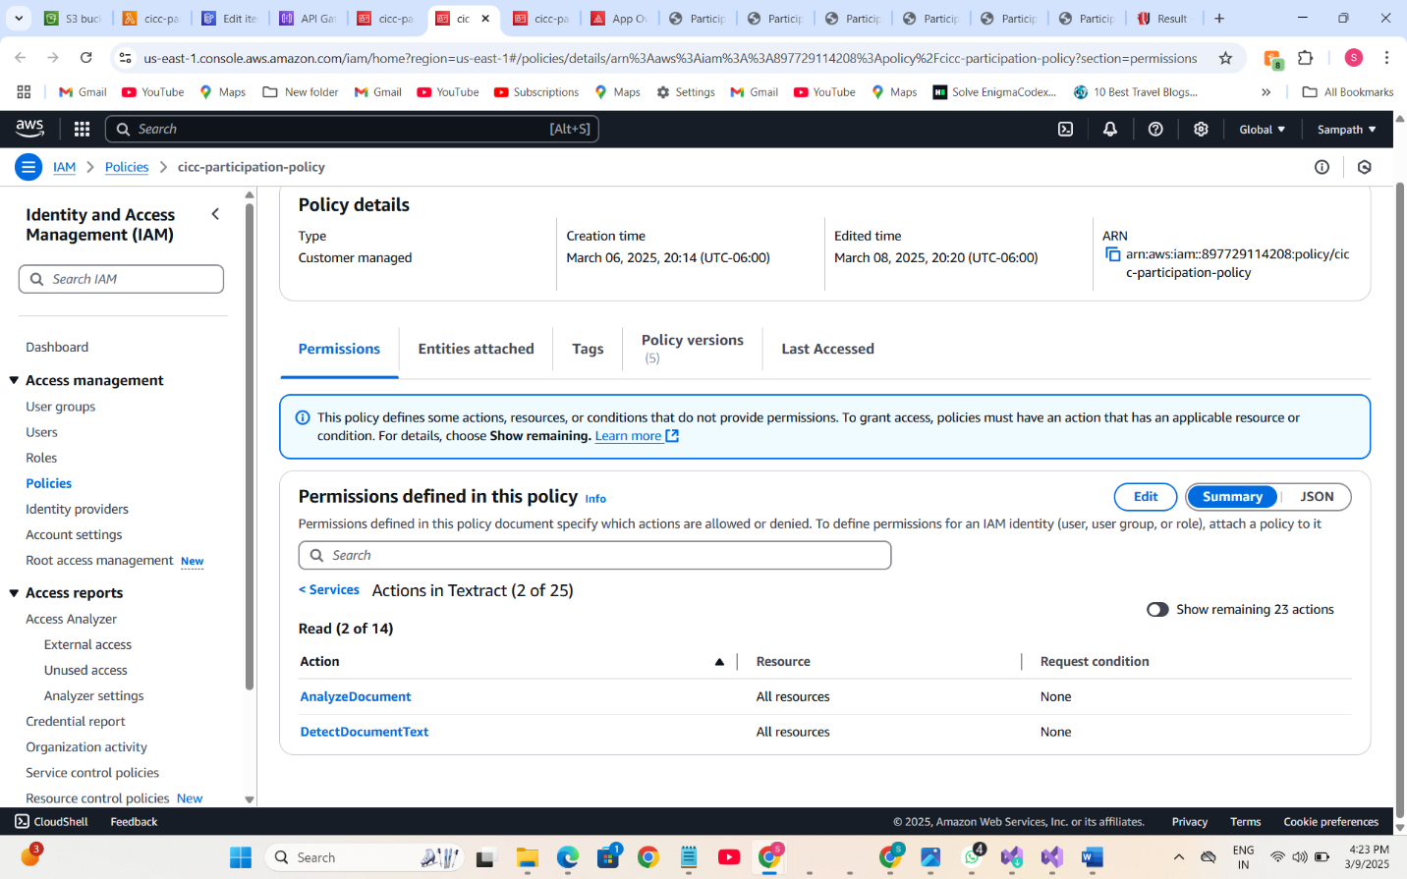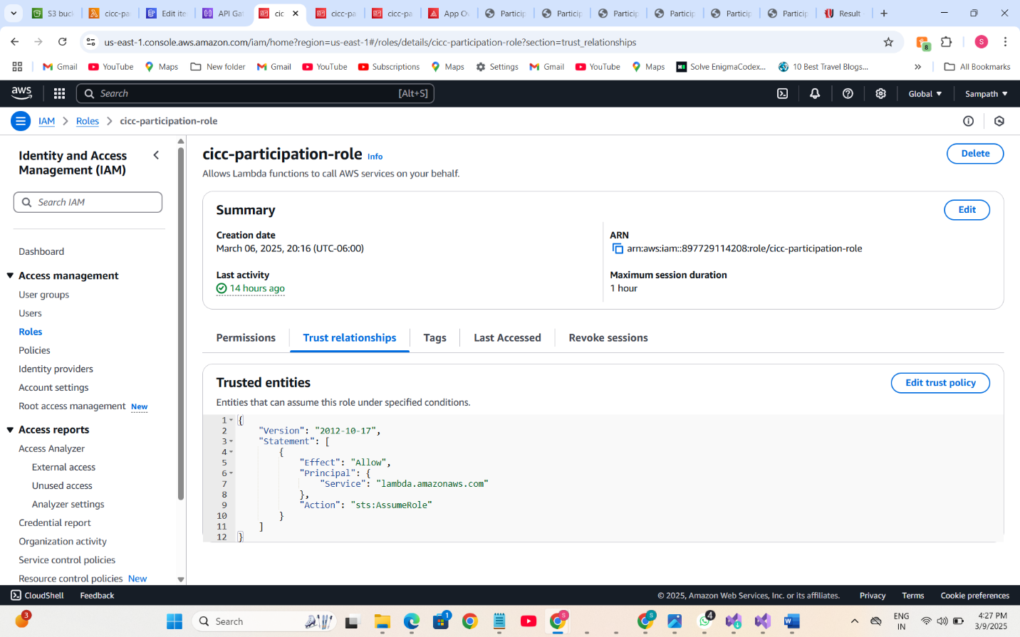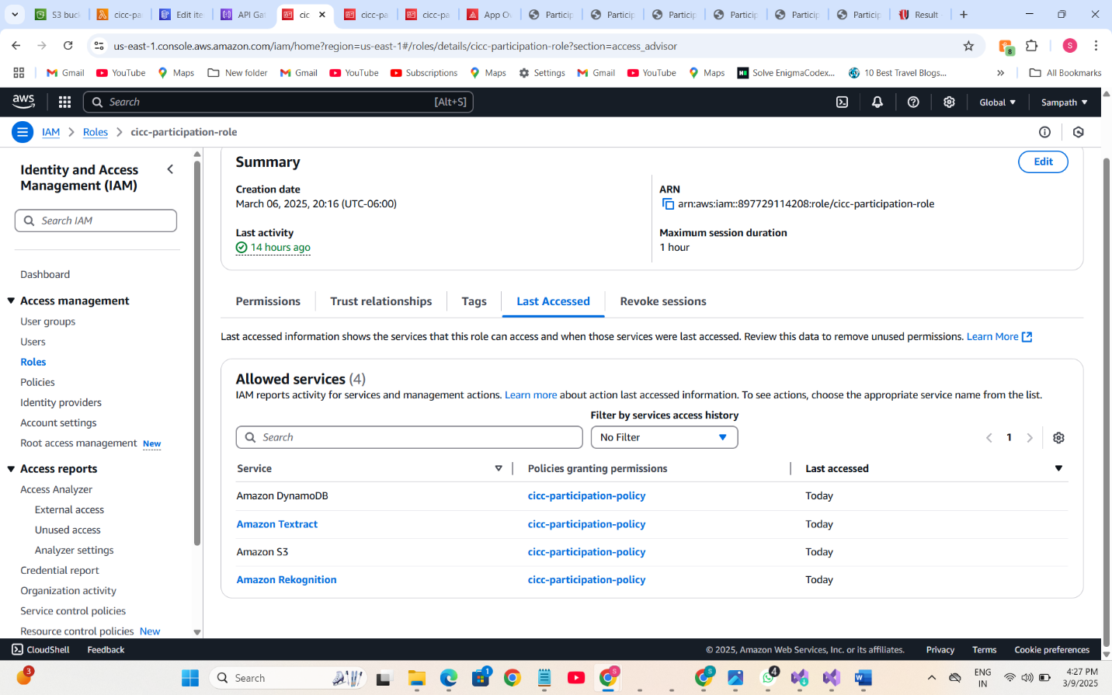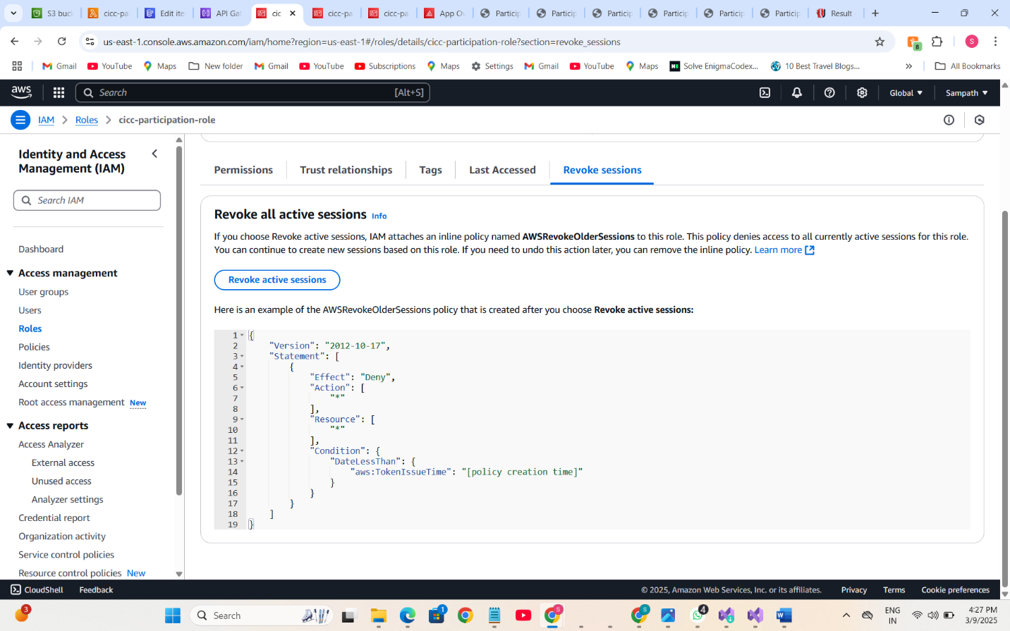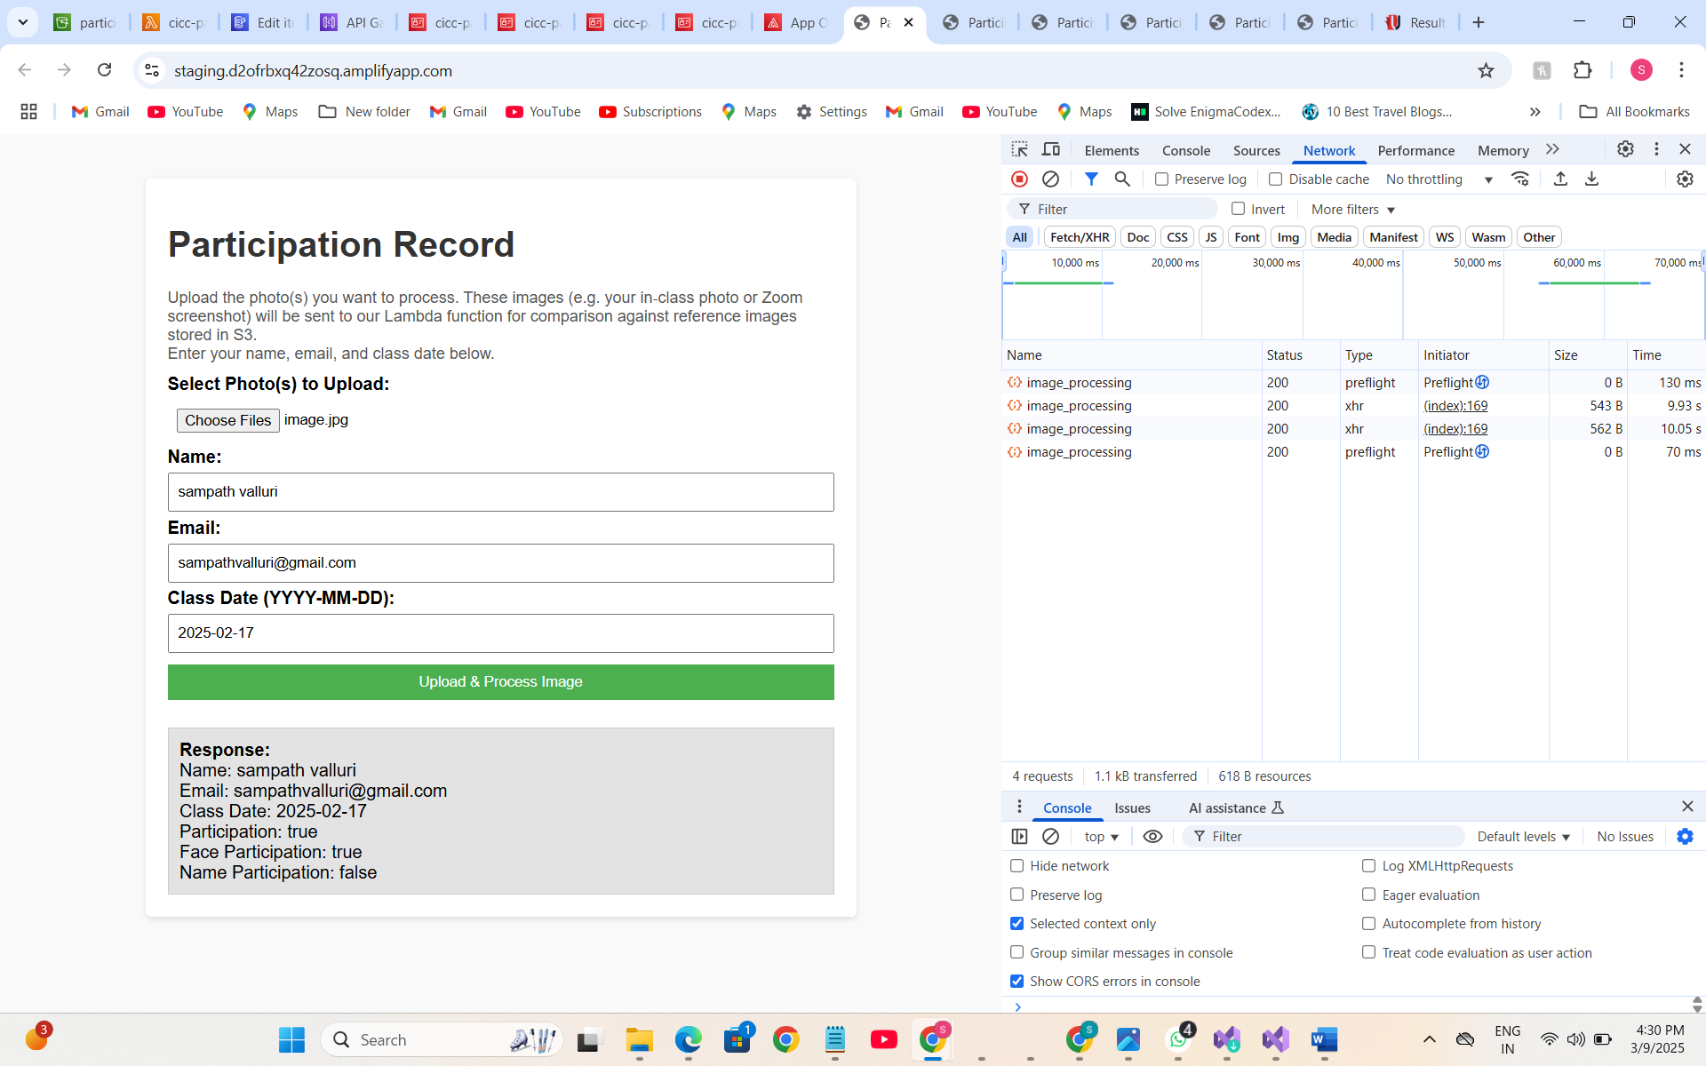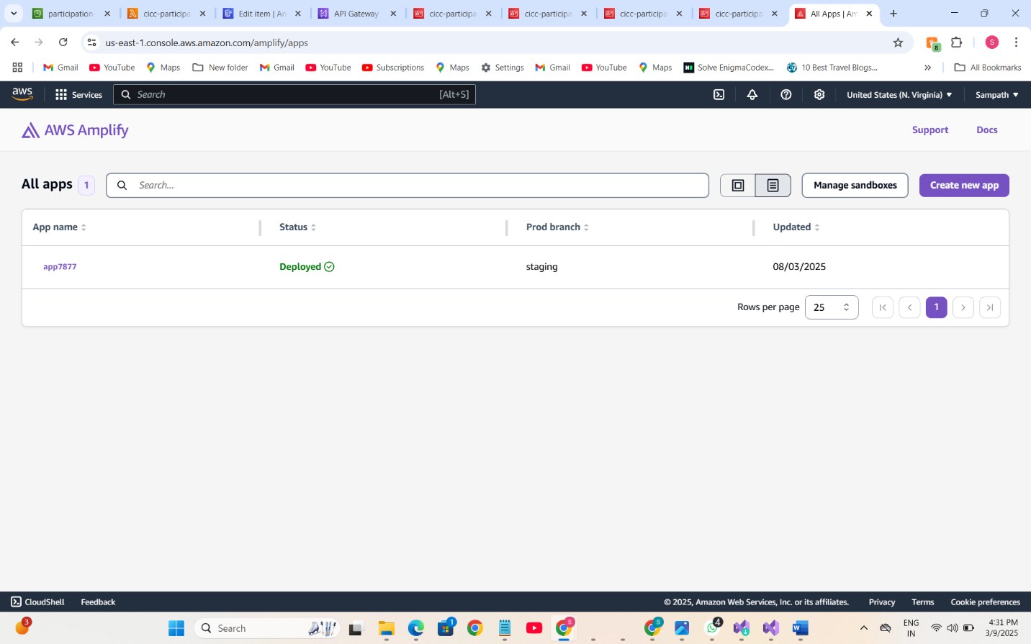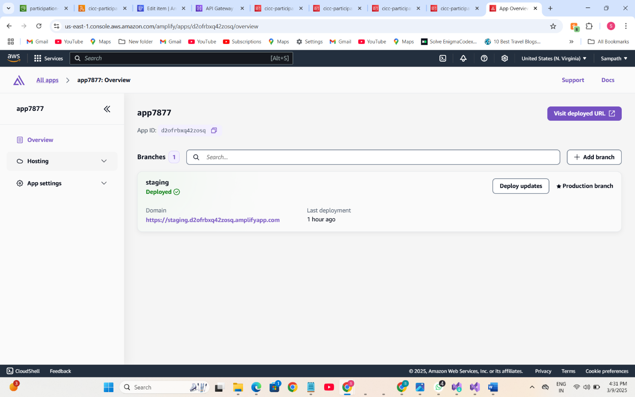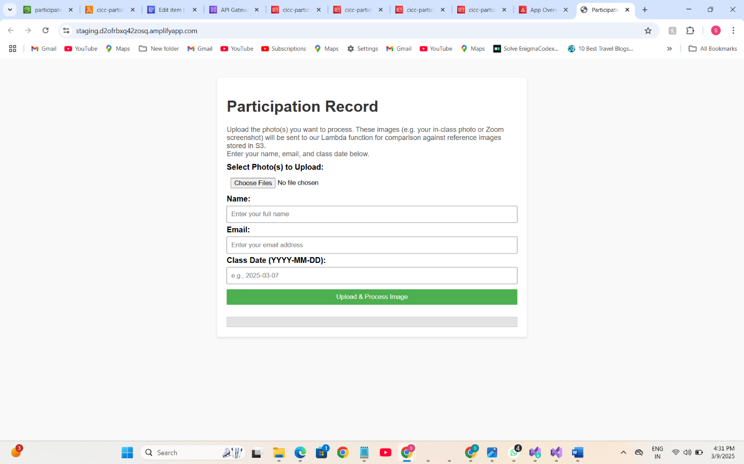

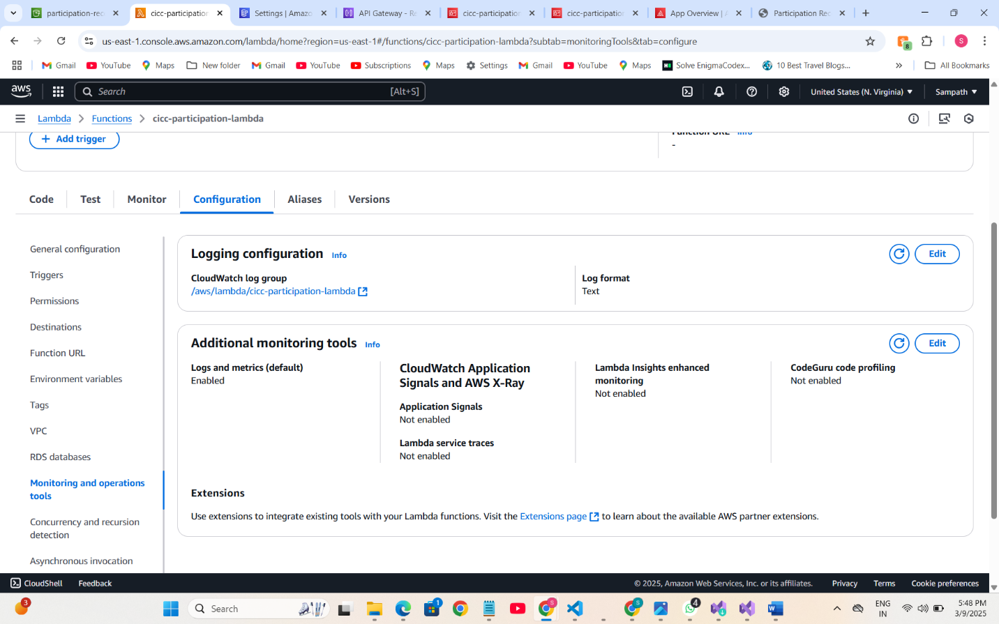

**4.**

**A)**

IAM (Identity and Access Management) is a free AWS service, meaning creating and managing IAM roles and policies does not incur costs.

Lambda: AWS Lambda offers 1 million free requests per month and 400,000 GB-seconds of compute time, which is ample for a student project with minimal traffic.

API Gateway: The free tier includes up to 1 million API calls per month, covering the expected usage.

S3: AWS S3’s free tier provides 5 GB of standard storage along with generous allowances for GET and PUT requests, which is sufficient for storing and retrieving a few images.

DynamoDB: The free tier offers up to 25 GB of storage along with enough read/write capacity for low-traffic applications like this project.

Textract and Rekognition: These services include free tier usage (subject to monthly limits) for tasks like text extraction and face detection. Given the limited number of images processed during development and testing, the usage remains well within the free tier boundaries.

By carefully selecting free-tier eligible services (t2.micro, 5GB S3 storage, IAM), ensuring data transfer remains within AWS, and monitoring usage via the AWS Free Tier Dashboard, I can confidently confirm that this project remains within the AWS Free Tier and will not incur charges.

**B)**

**Resource Cleanup:** After completing testing and project submission, you can delete or shut down all AWS resources (Lambda functions, API Gateway endpoints, S3 buckets, and DynamoDB tables) to prevent ongoing charges.

**Remove Custom IAM Roles/Policies:**

Delete any custom IAM roles or policies created specifically for this project. This avoids accidental usage or permissions that might trigger other services.

**Monitor Billing and Set Up Alerts:**

Enable AWS Budgets and billing alerts. These tools can help you monitor your usage and get notified if you’re approaching any free-tier limits or if unexpected charges occur.

**Cost Management Practices:** Use AWS Cost Explorer and budget tools to track usage and spending, ensuring that the project’s resource consumption stays within free tier limits.

**Minimal Configuration:** The project is designed to operate with the minimum configuration necessary, so only the essential services are used, reducing the risk of inadvertently incurring costs.

**C)**

To confirm consistency in the project’s AWS configurations, the key information you need to verify includes:

**Resource Identifiers & Names:**The Lambda function code must reference the correct S3 bucket names (for both reference images and uploaded images), DynamoDB table name, and API Gateway endpoint.  
For example, the Lambda uses the bucket name “participation-record” and the DynamoDB table “cicc-participation-table.” These identifiers must match exactly with what is deployed.

**IAM Roles & Policies:**The Lambda execution role must have permissions for S3 (GetObject, PutObject), Rekognition (DetectFaces, CompareFaces), Textract (DetectDocumentText), and DynamoDB (PutItem).A screenshot of the IAM role (showing the attached policy with these actions) confirms that the function is not over-privileged and is consistent with the project requirements.

**API Gateway Configuration:**The endpoint URL, resource methods (POST), integration type (Lambda proxy), and CORS settings should all be configured correctly so that the frontend communicates seamlessly with the Lambda function.A screenshot of the deployed API Gateway stage (with the correct URL) verifies that the configuration is as intended.

**Lambda Function Settings:**A screenshot of the Lambda configuration page (with these details) ensures the function is properly tuned for the workload.

**DynamoDB Table Details:**Confirm that the table’s name and primary key (e.g., email, classDate) in the DynamoDB console match what the Lambda code writes to.A screenshot of the DynamoDB table’s settings, including its ARN and key schema, verifies consistency.

**Example Explanation Using Screenshots:**API Gateway Deployment Screenshot:A screenshot of the API Gateway console displays the deployed API stage, the resource method (POST), and the endpoint URL.

By capturing and reviewing these screenshots, I can verify that every component of AWS infrastructure is consistently configured.

**D)**